

INDUSTRIAL PLANTS AND SAFETY

Preliminary study of an assembling plant

FINAL REPORT

TEAM 4

|  |  |  |  |
| --- | --- | --- | --- |
| ***Sub-Team*** | ***Students*** | | |
| ***Last name*** | ***First name*** | ***Matricola*** |
| *A HAIRDRYER* | *Marchisio* | *Federico* | *244654* |
| *Umerov* | *Enver* | *251223* |
| *La Ciacera* | *Salvatore* | *246883* |
| *Gulyamov* | *Ayubkhon* | *249338* |
| *B ELECTRICRAZOR* | *Rafiq* | *Hafiz Muhammad Usman* | *254031* |
| *Chatraband* | *Aditya Sunil* | *250550* |
| *Swami* | *Shubham* | *253749* |
| *Vadodaria* | *Milesh* | *250161* |
| *Yedigeyeva* | *Liana* | *275657* |

***Under the guidance of,***

***Prof. Alessandro Chiaraviglio***



***TEAM A – HAIRDRYER***

*Federico Marchisio 244654*

*Enver Umerov 251223*

*Salvatore La Ciacera 246883*

*Ayubkhon Gulyamov 249338*



***TEAM B – RAZOR***

*Shubham Swami S253749*

*Milesh Vadodaria S250161*

*Hafiz Muhammad Usman Rafiq S254031*

*Liana Yedigeyeva S275675*

*Aditya Sunil Chatraband S250550*

***Table of contents page***

1. ***Understanding the Specifications***

# ***Assumptions***

*Because of the student’s lack of direct contact with the industry, and therefore the absence of specific pieces of information, several assumptions are made:*

1. *All workers follow safety regulations relevant to the workplace.*
2. *Workers are highly skilled, and therefore capable of carrying out a variety of tasks relating to assembly and inspection of the hairdryer and the razor.*
3. *There are no damaged components (raw materials), said components are received in boxes with labels indicating the component number.*
4. *Parts placed in open boxes while travelling from one workstation to another will not be damaged from the movement.*

## ***The Problem***

*A team of eight students is to design a plant for the production and assembly of hairdryers and electric razors for use in regional peripheral warehouses, shopping malls and shops for XX S.p.A. This includes planning for the receipt of raw materials, transport of said raw materials to the assembly line, planning the with attention to detail (describing workstations, employee facilities, inspections, and more), packaging, storage and other miscellaneous activities.*

*This report will consist detailed study of few key factors for the main report such as understanding the flow of Incoming and Outgoing material by analyzing the procurement of raw materials, and its storage. As well as shipment of the finished product to the customers. It will also discuss creation of a complete multi-level hierarchical Bill of Material (BOM) for the production and determining the assembly process through it by evaluating all the operations needed to obtain the finished products. Furthermore, we will also determine the cycle times for all the operations in the process and understand the overall flow of raw materials (components).*

# ***Calculation of Material Flow***

**Calculation of outcoming flow (Demand)**

*Demand for each product was calculated using an algebraic equation provided by the text of the project:*

$$Demand=P={\left(\frac{\sum_{i=1}^{S}{C_{i}}}{S}+\frac{\sum_{i=1}^{S}{N_{i}}}{S}\right)*StP}/3$$

*Where $P$ is production required for each product, $C_{i}$ is the number corresponding to the English alphabetical letter of the initial letter of surname of the $i$-member team, $N_{i}$ is the number corresponding to the English alphabetical letter of the initial letter of name of the team member, $S$ is the number of students in the sub-team and $StP$ is the (required) standard production.*

|  |  |  |  |  |  |  |  |
| --- | --- | --- | --- | --- | --- | --- | --- |
| ***ELECTRIC RAZOR*** | | | | ***HAIRDRYER*** | | | |
| ***Last name initial*** | ***First Name initial*** | ***Ci*** | ***Ni*** | ***Last name initial*** | ***First name initial*** | ***Ci*** | ***Ni*** |
| *Y* | *L* | *25* | *12* | *M* | *F* | *13* | *6* |
| *C* | *A* | *3* | *1* | *U* | *E* | *21* | *5* |
| *V* | *M* | *22* | *13* | *L* | *S* | *12* | *19* |
| *S* | *S* | *19* | *19* | *G* | *A* | *7* | *1* |
| *R* | *H* | *18* | *8* | *-* | *-* | *-* | *-* |
| ***Average*** | | ***17.4*** | ***10.6*** | ***Average***  *Table 2.1* | | ***13.25*** | ***7.75*** |

*The figures for the average $C_{i}$ and $N_{i}$ are reported in table 1. The figure of the required standard production ($StP$) was provided by the assignment, which, for the* ***hairdryer, is 145.000 units/year*** *and for* ***Electric Razor is 232.000 units/year***

*Using the formula, the yearly ideal demand comes out to be* ***1.015.000 units for Hairdryer*** *and* ***2.165.333 units for electric razor*** *as reported in table 2.2. However, due to a 3% scrap rate, this figure differs from the raw materials flowing into the assembly line. This calculation is tackled in the next section, material inflows.*

**Calculation of incoming flow**

1. **Hairdryer**

*Taking the 3% scrap rate into account, the yearly demand for raw materials comes out to be 1.046.392 units (if there is only one of said raw material in the assembly). However, this figure comes with the assumption ‘workers may leave parts on the assembly line at the end of working hours’, as when the daily rate of assembly is computed, the result is a decimal. Due to this being a potential hazard, and accounting for raw materials and finished goods inventory being much easier when no components are undergoing assembly, it is assumed daily production rate should be an integer, hence it was computed and rounded up, to then be once again translated into hourly, weekly and yearly rates, in table 2.2.*

|  |  |  |
| --- | --- | --- |
| *Standard Production* | *145.000* | *units/year* |
| *Average Ci* | *13,25* |  |
| *Average Ni* | *7,75* |  |
| *Production Required* | *1015000* | *units/year* |
| *Working days* | *220* | *days* |
| *Working hours per day* | *8* | *hours* |
| *Scrap Rate* | *3%* |  |
| *Units Required to meet demand* | *1046392* | *units/year* |
| ***Units Produced (Theory)*** |  |  |
| ***Per Day*** | *4757* | *units/day* |
| *Per Year* | *1046540* | *units/year* |
| *Per Week* | *23785* | *units/week* |
| *Per Hour* | *594,63* | *units/hour* |

*Table 2.2*

*Naturally, this impacts the number of actual units produced per year, which changes from 1.046.392 to 1.046.540. However, this figure is simply indicative, and serves as to show how many units would be assembled yearly if the daily rate of assembly was required to be 4.575 on all days. In reality, the assembly line would halt operations the moment it fulfilled the number of required orders (demand), but this figure serves as an indication as to what capacity the assembly line must be capable of operating at and will be useful for future reference. However, to calculate material inflows, the figure 1.046.392 units will be used as it corresponds to the demand (Table 2.3)*

|  |  |  |  |  |  |  |  |
| --- | --- | --- | --- | --- | --- | --- | --- |
| ***Nr.*** | ***Component*** | ***Quantity*** | ***Pieces Required (per week)*** | ***Nr.*** | ***Component*** | ***Quantity*** | ***Pieces Required (per week)*** |
| *1* | *Nozzle* | *1* | *23782* | *16* | *Diode* | *1* | *23782* |
| *2* | *Front body* | *1* | *23782* | *17* | *Connection line* | *4* | *95127* |
| *3* | *Air-exit net* | *1* | *23782* | *18* | *Mini screw* | *7* | *166472* |
| *4* | *Absorbing capacity pad* | *2* | *47564* | *19* | *Thermal output* | *1* | *23782* |
| *5* | *Inner body* | *1* | *23782* | *20* | *Connect copper* | *1* | *23782* |
| *6* | *Grill* | *1* | *23782* | *21* | *Voltage drop wire* | *2* | *47564* |
| *7* | *Heater* | *1* | *23782* | *22* | *Mica plate* | *2* | *47564* |
| *8* | *Mica plate holder* | *2* | *47564* | *23* | *Mini switch* | *1* | *23782* |
| *9* | *Septa* | *1* | *23782* | *24* | *Push button* | *1* | *23782* |
| *10* | *Motor* | *1* | *23782* | *25* | *Switch* | *2* | *47564* |
| *11* | *Screw type 1* | *2* | *47564* | *26* | *Screw type 3* | *2* | *47564* |
| *12* | *Fan* | *1* | *23782* | *27* | *Fixer* | *1* | *23782* |
| *13* | *Back body* | *1* | *23782* | *28* | *Sheath* | *1* | *23782* |
| *14* | *Air entrance* | *1* | *23782* | *29* | *Power plug* | *1* | *23782* |
| *15* | *Screw type 2* | *2* | *47564* |  |  |  |  |

*Note that the numbers are rounded, hence not exactly the weekly values.*

1. **Hairdryer**

The “Raw Materials” for Electric Razor, as shown in the figure 2.1, are directly acquired in form of 15 pre-manufactured components from the manufacturer as well as cardboard sheets.

The pre-manufactured parts that arrive as raw materials are as follow, numbers are to be used as reference in following report.

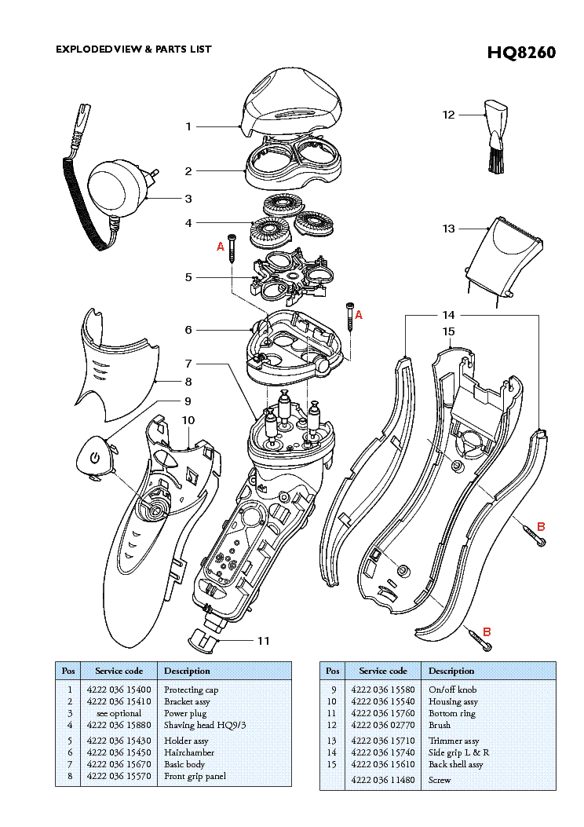

1. Protection cap

2. Bracket assy

3. Power plug

4. Shaving head set of 3

5. Holder assy

6. Hairchamber

7. Basic Body

8. Front grip panel

9. On/Off knob

10. Housing assy

11. Bottom ring

12. Brush

13. Trimmer assy

14. Side grip L & R

15. Back shell assy

Figure 2.1

To calculate the incoming flow, we determine the usage rate for each component and the request can be calculated as a product - **usage rate x demand**, where **demand** can be for any reference time. Since the daily demand is quite high and the shipment of product is scheduled thrice a week, to meet daily demands we have taken Daily calculation for reference time, and the **usage rate** is the quantity of the raw material needed to produce one finished product as reported in table below.

|  |  |  |  |
| --- | --- | --- | --- |
| ***Product/raw Materials/ Components: Electric Razor (Team B)*** | | ***Usage rate*** | ***Daily request*** |
|
| *B* | *Electric razor* |  | *10148* |
| *1* | *Protecting cap* | *1* | *10148* |
| *2* | *Bracket assy* | *1* | *10148* |
| *3* | *Power plug* | *1* | *10148* |
| *4* | *Shaving head* | *1* | *10148* |
| *5* | *Holder assy* | *1* | *10148* |
| *6* | *Hairchamber* | *1* | *10148* |
| *7* | *Basic Body* | *1* | *10148* |
| *8* | *Front grip pannel* | *1* | *10148* |
| *9* | *On/Off knob* | *1* | *10148* |
| *10* | *Housing assy* | *1* | *10148* |
| *11* | *Bottom ring* | *1* | *10148* |
| *12* | *Brush* | *1* | *10148* |
| *13* | *Trimmer assy* | *1* | *10148* |
| *14A* | *Side grips L* | *1* | *10148* |
| *14B* | *Side grips R* | *1* | *10148* |
| *15* | *Back shell assy* | *1* | *10148* |
| *16* | *Screw* | *4* | *40592* |
| *17* | *Cardboard sheets* | *1* | *10148* |

* ***Shaving heads are ordered to arrive in a set of 3 heads, whereas the Side grips L&R arrive separately to make things easier for the workers during assembling process***
* **Raw material for packaging box arrives as cardboard sheets.**
* **Screws A and Screws B are similar screws of type and length to simplify the design and assembly process**

# ***3. Planning the Assembly***

## ***HAIRDRYER***

## ***Assembly (Exploded View)***

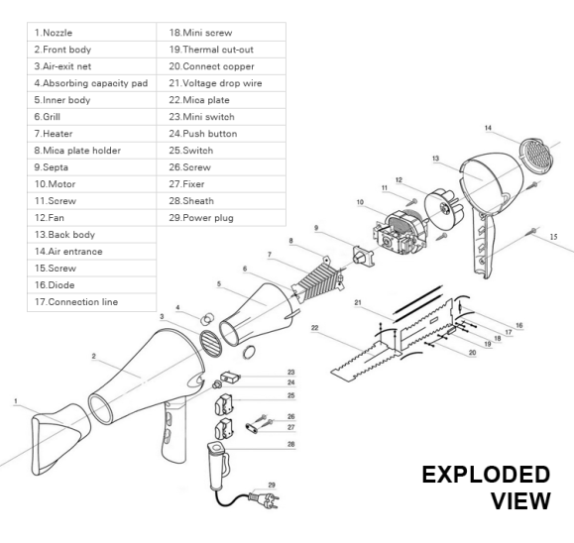

## ***BOM***

Main Assembly

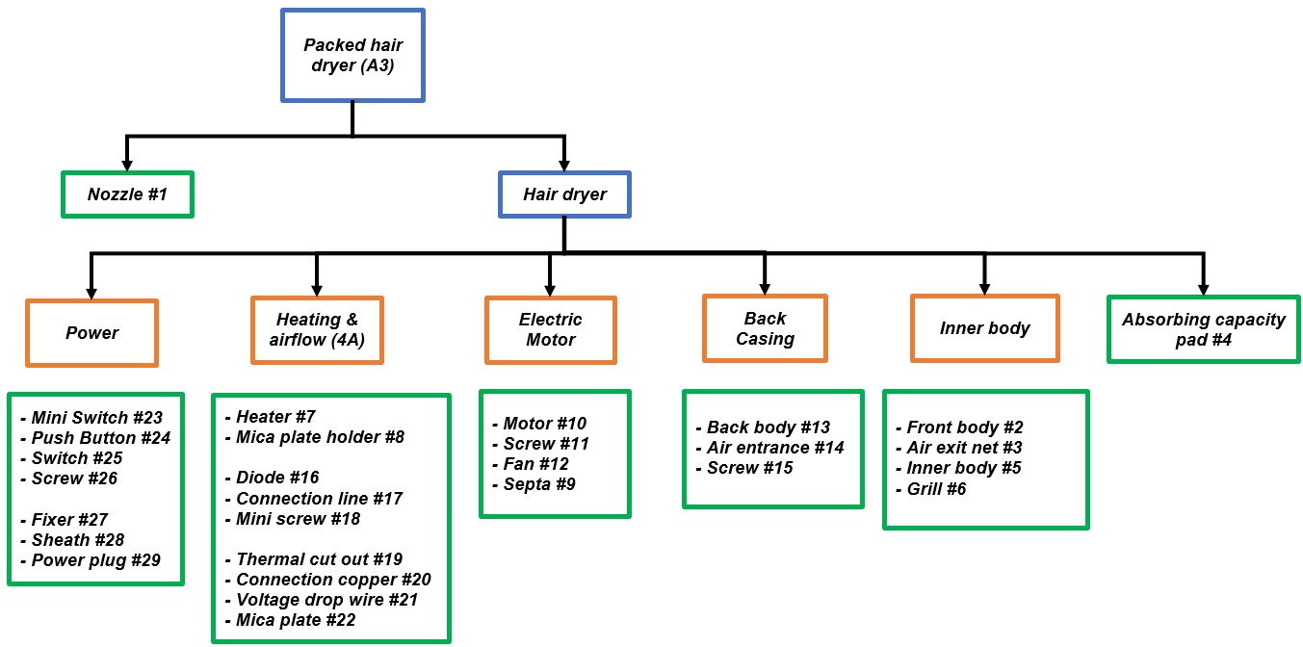

Children (Raw Material)

Sub-Assembly

## ***Assembling Process***

*The assembly process and cycle time values are based on the data provided by Value Stream Mapping case study referenced at the end of the report.*

*The values are considered typical for the general hairdryer production.*

*Once the raw materials are taken from their containers (which takes around 1 minute), the assembling process begins. Since 4A is preassembled, the first step involves mounting the other components of the hairdryer’s interior (3, 5, 6, 9, 10, 11, 12) onto 4A and perform wire connection with heater assembly, after that end cap is crimped in order to assure firmness between the wire system and the inner side of the body. This operation takes approximately 36 seconds considering the employee is highly skilled.*

*After a visual inspection, which takes 10 seconds, A1 proceeds to the next workstation via conveyor belt where it is placed in the front outer body along with the other components. The routing of wire is done in the holes and the notches are made to make the wiring firm from the interior to the outside of hair dryer. The handle components are inserted in the front body’s handle. Lastly, the rear of the hairdryer’s external body is fixed to the rest of the hairdryer with two screws. The whole operation takes 25 seconds.*

*A3 is then inspected for 5 seconds before proceeding to the packaging section and finally the finished goods storage.*

## ***Raw Material Organization***

*Upon arriving to XX S.p.A., the raw materials are organized in a raw materials storage based on their component number as to facilitate future operations. Once needed, the containers*

sec

sec

*are carried via forklift*

*to the workstations they are required. Each raw material comes in different quantities in one of the three container types (type 1, 2 or 3), which all have different dimensions. The quantity of RM per container and the container type are outlined in table 3.1.*

*Table 3.1*

*The size of each raw material was calculated on the base of real measurements, and therefore slightly approximated.*

1. **RAZOR**

**Determination of Hierarchical Bill of Material**

To plan the purchase of raw materials and to define subassemblies-assembly tree for the assembly of Electric razor the proposed multilevel BOM is as follow

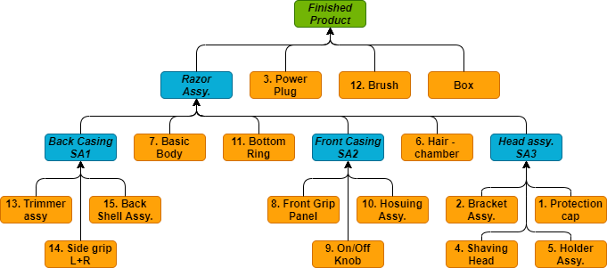

*Shows all the components required for the assembly. Requirement of all the components in this chart is* ***X1*** *for assembly of one product Keeping in mind that 4. Shaving heads arrive in a set of 3, and 14. Side grips are set of 2 side grips, L & R*

*Shows subassemblies made from the components. Also, requirement of these all subassemblies in this chart is* ***X1*** *for assembly of one product*

*Is the finished product which also includes the packaging of cardboard box that needs to be done for the electric razor and other packaging components.*

**Assembling process**

*To get the bird’s eye view of the whole assembling process to better understand how parts go together and to help plan the whole assembly line, a schematic model we are using to explain the assembly process:* ***Assembly Chart***

* ***To help plan this chart and decide assembly process, we have disassembled and assembled a fairly similar product from Philips* (AT620) *and have taken assembly efficiency as a primary consideration.***

*Upon our study and conclusions, we have come with what feasible step by step assembly of the Electric Razor should looks like, and we are going to follow in this assembly plant:*

1. *Take* ***Back shell assy****, as it provides* ***base*** *to back casing parts*
2. ***Side grips L & R*** *then gets* ***snap fitted*** *in their respective places*
3. *Next,* ***Trimmer assy,*** *as it requires* ***add and hold down****, finishes this* ***Back casing assembly***
4. ***Basic body*** *is taken to provide* ***base*** *to the whole razor assembly*
5. ***Back casing assembly*** *gets easily inserted to the basic body then immediately gets secured by* ***screw fastening,*** *trimmer assy gets secured here as well*
6. *Take* ***Housing assy****, as it provides* ***base*** *to front casing parts*
7. ***On/Off knob*** *easily gets* ***snap fit*** *operation done on housing assy and holds its place*
8. *Similarly,* ***Front grip panel****’s insertion with* ***snap fit*** *concludes firm* ***front casing assembly***
9. ***Bottom ring*** *gets attached to previous A1 assembly at the bottom, as it requires* ***insertion and holding down***
10. ***Front casing assembly*** *gets inserted and secured through* ***snap fit*** *with assembly, which also secures the position of bottom ring*
11. ***Hairchamber*** *then gets inserted, it holds its place and secures place by* ***screw fastening***
12. 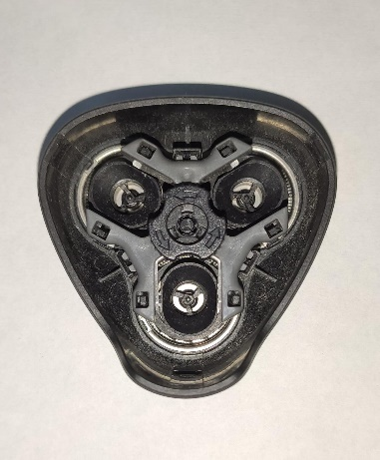***Holder assy*** *comes in hand as being the* ***holder*** *to head assembly*
13. *Three* ***Shaving heads****, being identical, takes their place in any random*

*holes of holder assy by simple* ***placing and holding*** *operation*

1. ***Bracket assy*** *easily* ***snap fits*** *into holder assy, together with closing*

*shaving heads between them*

1. *Easy* ***snap fitting*** *of* ***Protection cap*** *finishes* ***Head assembly***
2. *This* ***Head assembly*** *then finished* ***Razor Assembly*** *with simple* ***snap fit***

*Operation. (head assembly*

1. ***Power Plug*** *being a separate component will require simple* ***insertion in the box***
2. *same goes for the* ***Brush****, it will require simple* ***insertion in the box***

|  |
| --- |
| *Based on the feasible assembly of the electric razor that has been proposed above and the availability of the tools and machinery for this plant, with that keeping mind to have the unidirectional flow of the materials as well as the process, below is the assembly chart that defines and helps out product assembly process*  A screenshot of a cell phone  Description automatically generated***Assembly Chart*** |
|  |

**Cycle time of operations**

*For defining cycle time for each operation, certain things and some assumptions have been taken to improve efficiency of the plant, which are as follow:*

* *For the supplies of Raw material*
  + - *Raw materials are of high quality, no defects, no checks required*
    - *Parts received are well organized inside containers*
    - *All parts especially side grips L&R come well colored labeled*
* *For assembly process*
* *Assembly is* ***purely manual****, except for the cardboard box which assembled by high speed cardboard box assembly machine*
* ***Conveyer belt*** *has been used to transfer assemblies from one workstation to another and it is* ***unidirectional,*** *worker may walk along the belt during assembly*
* *Workers are* ***highly skilled***
* *Parts are well* ***within workers reach****, and containers are already* ***loaded at the workstations***
* ***Parts don’t tangle or nest inside the containers, do not stick together and are not fragile***
* *Screws are fastened by* ***power tool***

*So, to define the cycle time for each operation we taken into considerations manual handling time, tool acquire time, and insertion time for each part/subassembly*

*For each of those sub operations we define time using the tables found on DFA guidelines for assembly plants*

* ***For handling time***  *includes load to workstation time, add-ons, put back in place time, unload from the workstation (if required)*

*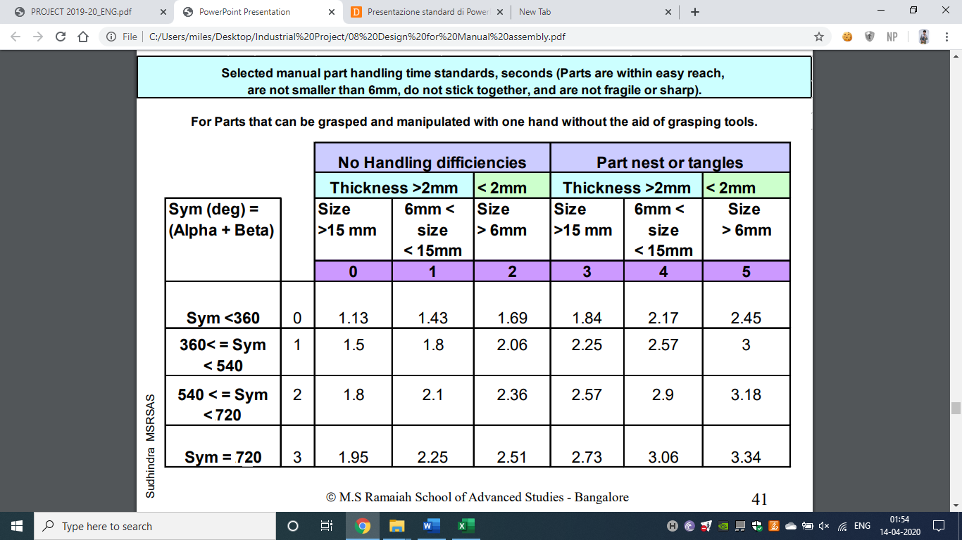****Alpha (α)*** *symmetry depends on the angle*

*through which a part must be rotated*

*about an axis perpendicular to the axis*

*of insertion to repeat its orientation*

***Beta (β)*** *symmetry depends on the angle*

*through which a part must be rotated*

*about the axis of insertion to*

*repeat its orientation*.

* ***For Insertion time***

*To decide time taken for insertion these tables have been used.*

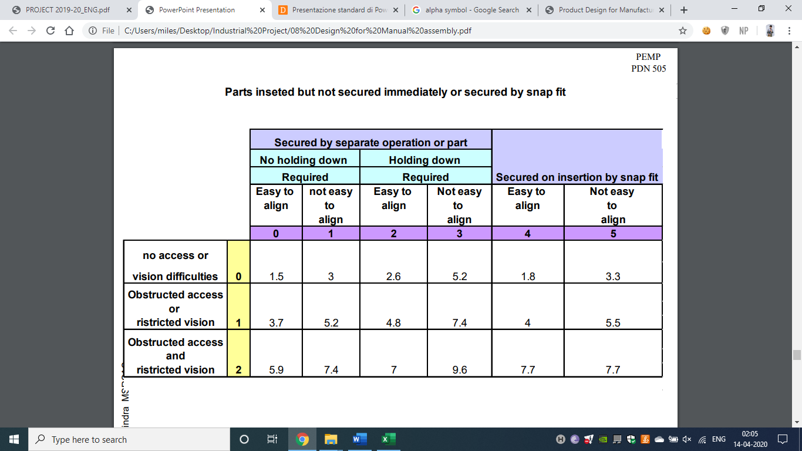

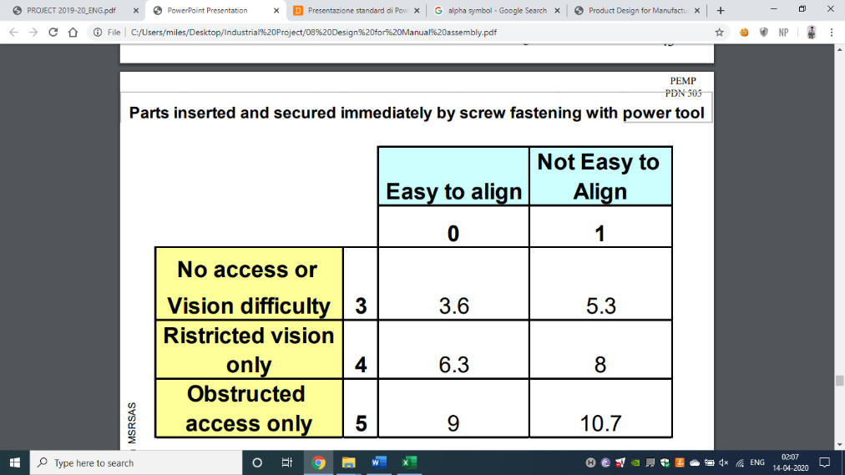

* ***Tool acquire time (Power tool)***

*Tool acquire time for power tool from above Handling time guide table comes out as* ***1.95s***

* ***Screw Fastening time***

*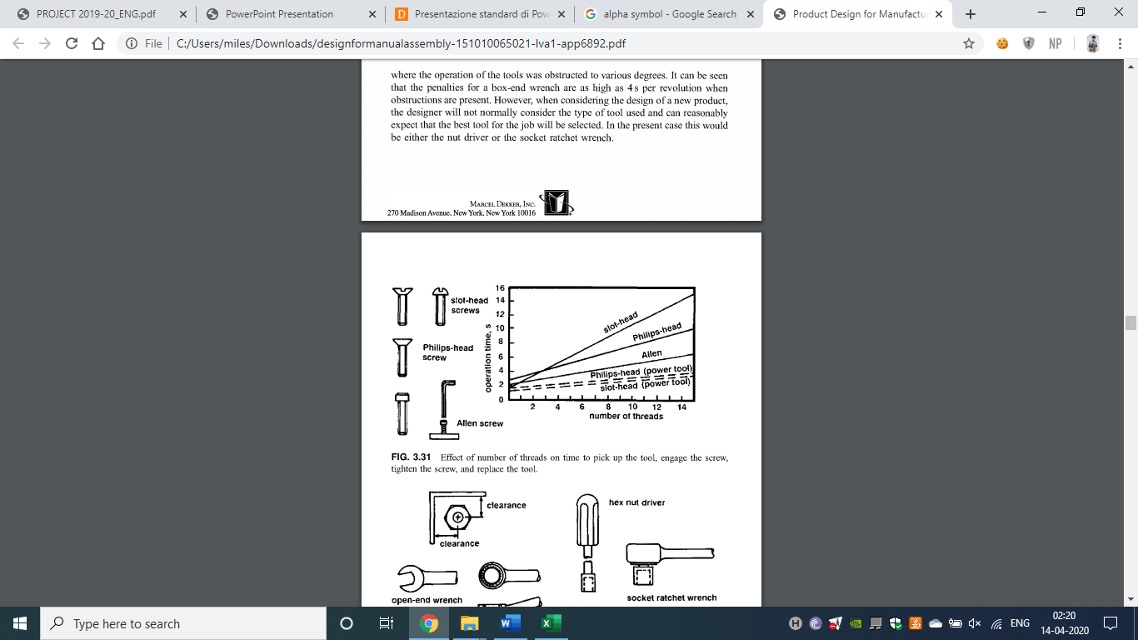With the help of this graph*

*Or Philips head screws, 6 threads,*

*using Power tool will take* ***2s*** *each*

* ***Inspection time***

*with a simple pickup and put back, during*

*the assembly process, in line inspection will*

*takes* ***2s****, taken handling time as consideration from handling time table from above*

* ***Carboard box assembly***

*For the assembly plant, to assemble the cardboard boxes from cardboard sheets*

***A high speed fully automatic corrugating machine*** *has been ordered by one of the key manufactured machine suppliers and has been designed to Corrugate, print and laminate the box as per need with the speed of* ***30 pieces/min***

*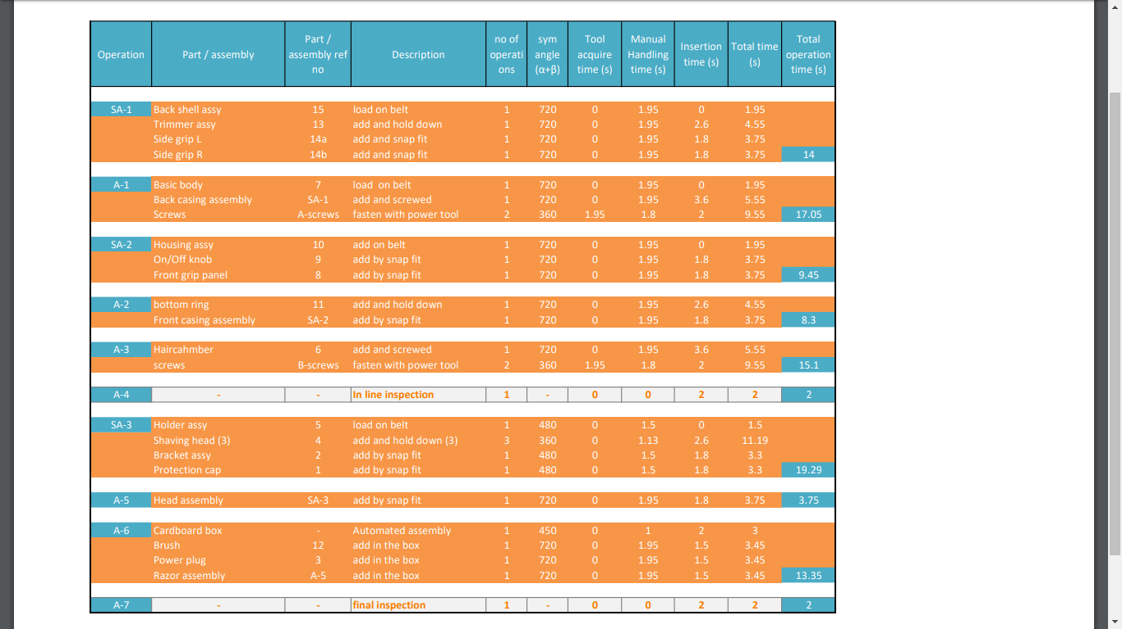With all these, gives us the table.*

|  |  |  |  |  |
| --- | --- | --- | --- | --- |
| Cycle time for product assembly | 104.29 | seconds |  |  |

*Considering ideal time of 3s for each part of the assembly,*

*total of 23 parts (18 raw components incl 3 heads and 2 grips + 4 screws + cardboard box)*

**Design efficiency** = $\frac{Ideal assembly time}{Actual assembly time}$ = $\frac{3 ×23}{104.29}$ = **0.66**

**BOM / Type-container size / Assembling operations table**

* ***Type-container size***

*Components, as raw material, from suppliers will arrive in protective casing and inside the containers.*

*Types of containers defined to pack these components are*

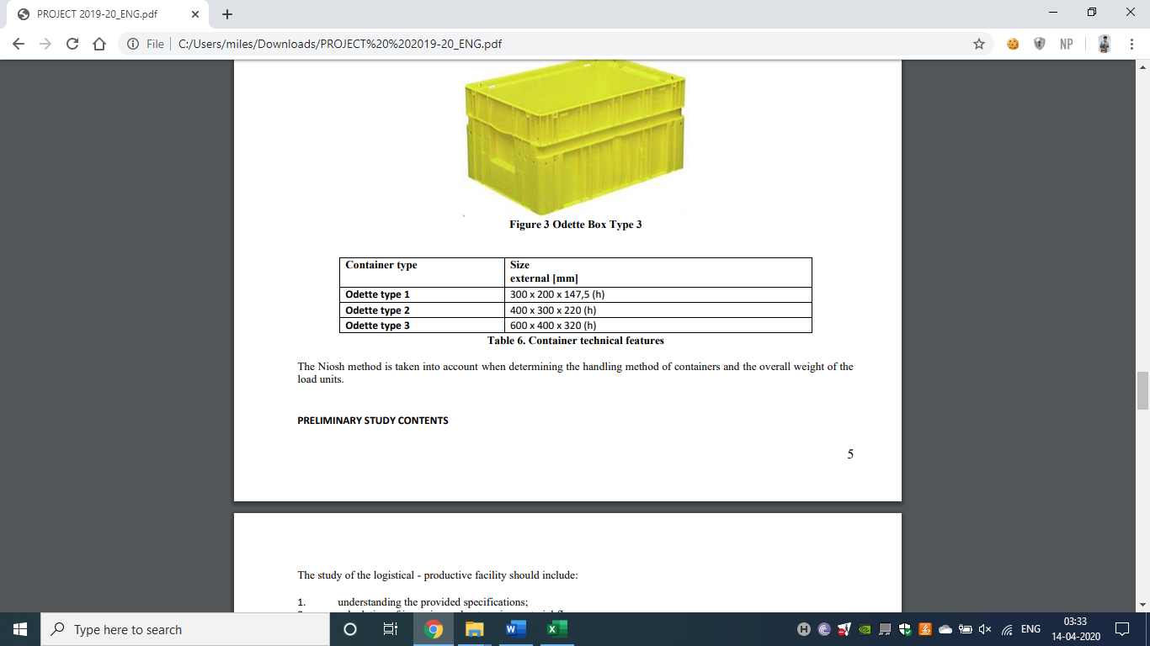

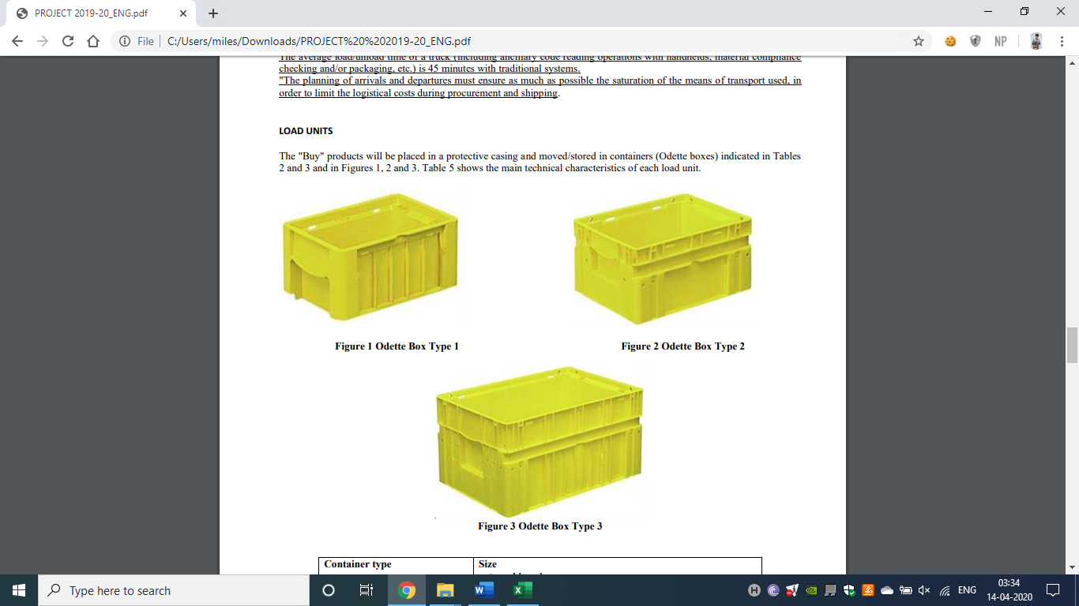



* *To define components that arrive from suppliers, their dimension, we have taken out similar product from Philips (AT620) and its disassembled parts as reference to our product’s and raw material/components’ dimensions.*

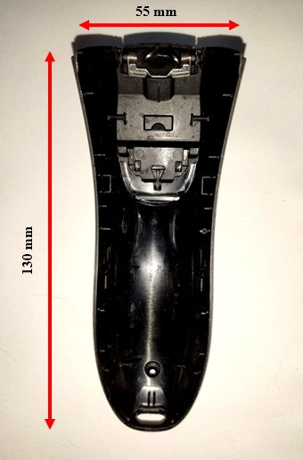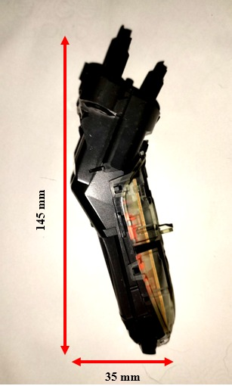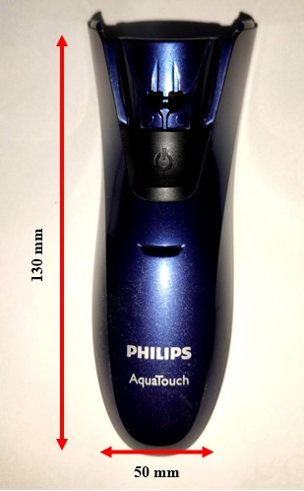

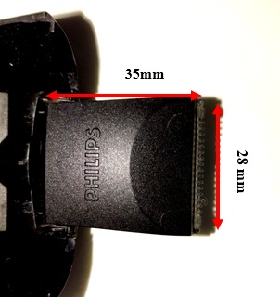

7. basic body 15. Back shell assy 10. Housing assy 13. Trimmer assy

14. side grips 8. Front grip panel

9. On/Off knob

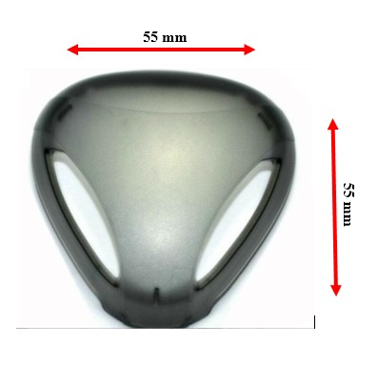

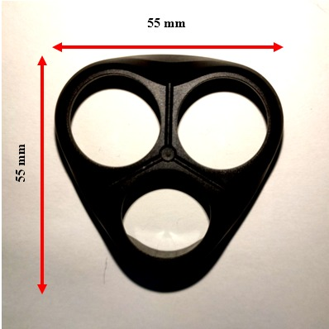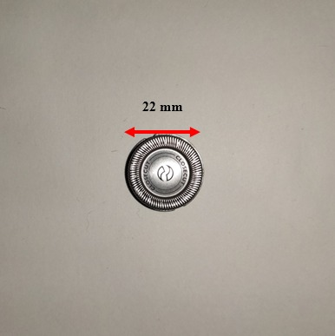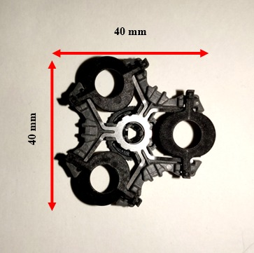

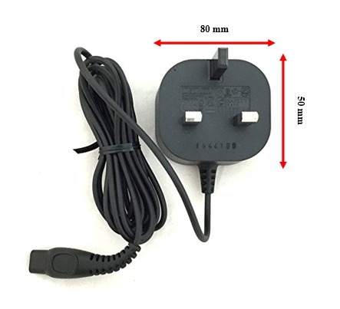5. Holder assy 4. Shaving head 2. Bracket assy 1. Protection cap

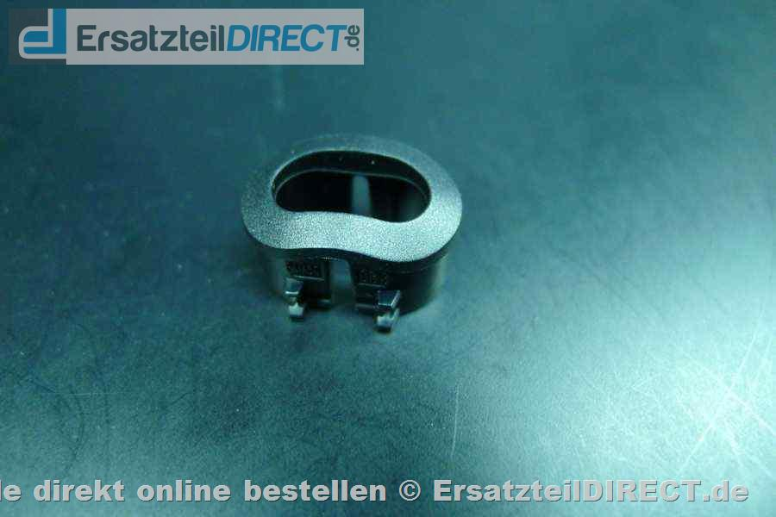

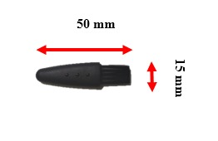12. Brush 3. Power plug 11. bottom ring

* *14. Side grips L&R, 8. Front grip panel, 9. On/Off knob’s separate pics not included but have been measured in similar fashion*
* *To have organized parts inside the containers, some breathing space has been given to the parts by not allowing containers to fill up to their maximum capacity. Feasibility according to the part size is taken as utmost consideration while deciding this breathing space*
* *For screws containers, of size of suppliers’ choice, holding 5000 pieces per container, and for cardboard sheets the stack of 100 cardboard sheets has been orders to have feasible to volume move around*

**Assembly operations**

*Data is taken from Table 3.1*

*Operations A4, A7 (inspections) not included in this table, keeping in mind that, A4 inline inspection check is of 2s, A7 finished product in line inspection check is of 2s*

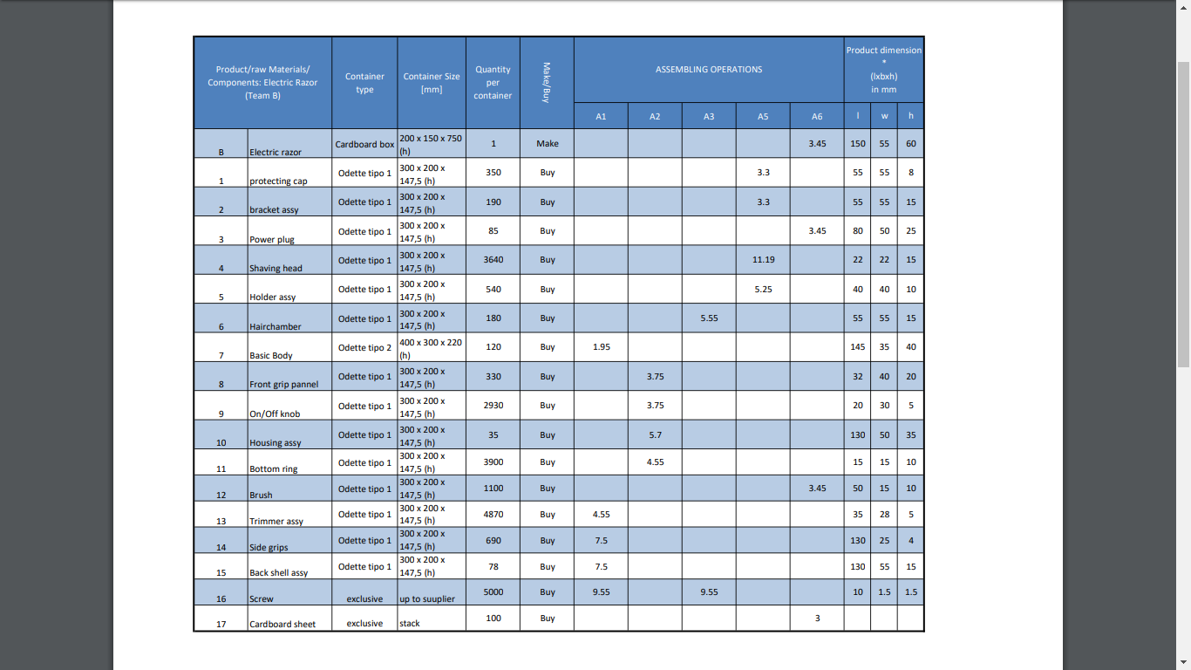 **BOM / Type-Container size / Assembling operations Table for Electric Razor**

# ***Production Process and Flows***

1. ***HAIRDRYER***

## *Description of the Production Process and Overall Flows*

*The production starts with the receipt of raw materials from the suppliers. The raw materials are first stored in the RM warehouse. Once they are requested for assembly, they are transported to the assembly line by means of a forklift. Different raw materials are transported to different workstations. The employees assigned to the transportation of raw materials ensure, upon reaching the desired workstation, they can be easily extracted from the containers by the employees assigned to the assembly. Generally, this operation takes about 1 minute at the beginning of the day and is repeated whenever required. The assembling process consists of two main operations and an inspection after each operation. The finished products are placed in card boxes processed by a separate (automated) workstation. This workstation processes unshaped cardboard boxes (received as raw materials) resulting in a box made to house a finished product. This box, with the product inside of it, will be stored in the finished goods storage.*

*The first operation [duration: 36s] consists of assembling the preassembled component (referred to as 4A, which is composed of the heater, mica plate holder, diode, connection line, mini screw, thermal out-out, connection copper, voltage drop wire, and mica plate) with the inner body group (which is composed of the inner body, grill and air-exit net) and the electric motor (which is composed of the septa, motor, screw and fan). This operation has the purpose of putting all the internal components (excluding handle-related ones) together. The main element holding this subassembly together are the type 1 screws (#11) that keep the motor (#10) fixed to the inner body (#5). This subassembly is then placed into an open box, which in turn is put on a conveyor belt carrying it to the next workstation.*

*After this first operation, an inspection [duration: 10s] is carried out by an employee to ensure the assembly meets the requirements of the product. This same employee carries out the second assembly operation.*

*In the second operation [duration: 25s], the product reaches completion. The external parts (front and back bodies, nozzle, air-entrance, screw, and absorbing capacity pad) are assembled onto the internal parts, and before the back body is placed into the assembly and screwed in, the ‘power’ parts (mini switch, push button, switch, screw, fixer, sheath and power plug) are assembled into the front body’s handle. Once the internal components of the handle (refers to the ‘power’ parts) are positioned into the front body’s handle properly, the back body can be screwed in and the assembly reaches completion. Once this happens, the product is once again placed into an open box, which in turn is put on a conveyor belt carrying it to the end of the assembly line.*

*At the end of the line, an employee will take the finished products from the box, inspect whether they meet the requirements or not [duration: 5s], and place these into the finished product boxes, [duration: 10s] Once they are enough to justify the use of a forklift, an ulterior employee will transport them to the finished goods storage.*

*In the moment goods need to be shipped out of the finished goods storage, the employees charged with transporting finished goods to the storage will momentarily put those duties on hold and use the forklifts to load the products into trucks used to deliver the goods. These will deliver the hairdryers to retail stores and warehouses that will sell them to their customers, bringing the flow of materials from supplier to customer to an end.*

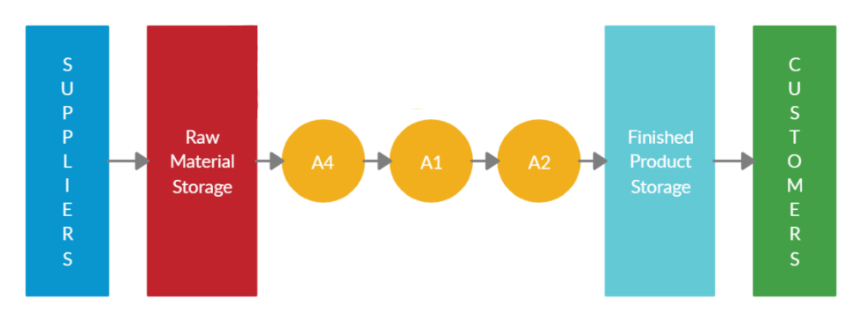

***Important things to note:***

* *If one assembly line is unable to output the demanded quantity of goods, there will be more of these lines running one alongside the other.*
* *Due to the skill of the workers, it is assumed the assembly workers will be able to perform the inspections of the product themselves.*

1. 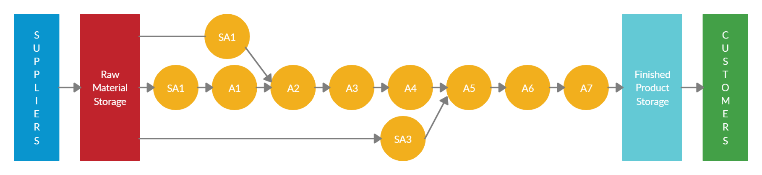**RAZOR**

*A ‘Buy’ order takes place to purchase all the required raw materials from the suppliers*

*Components will arrive in containers in trucks at assembly plant, which will be unloaded and will be then moved to Raw material warehouse*

*Continuous feeding of these components is done by feeders to their respective workstation*

*SA1: Snap fit of side grips to Back Shell assembly, proceeded by insertion of Trimmer assy to the Back shell assy takes place by the worker as Back casing assembly workstation and this sub assembly moves along the conveyer belt*

*A1: Back casing assembly gets fastened by screws to Basic body by the operator at first assembly workstation and feeds it to next workstation with the belt*

*SA2: Housing assy, On/Off knob and Front grip panel all gets assembled as Front housing assembly at their workstation by the operator and feeds it to next workstation through the belt*

*A2: First Bottom ring insertion takes place and while holding it in place, Front casing assembly insertion by the operator sets off the complete casing off body which then feeds to the next workstation through the best*

*A3: Operator screws Hairchamber on the previously assembly and feeds to the next workstation*

*A4: A worker quickly inspects the semi assembled product till now, just a visual check, and gives it a green signal to next workstation if everything seems at place*

*SA3: Holder assy places gets filled by 3 Shaver heads, immediately followed Bracket assy insertion and, Protection cap fitting completes the work of the operator at this workstation and then he feeds Head assembly to the next workstation through the belt*

*A5: Operator assembles semi assembly of the razor with the head assembly, and this operation completes Razor assembly, which gets fed to the next workstation*

*Cardboard box corrugator assembles and prints Cardboard box for the final assembly*

*A6: Feedings of Razor assembly along with Power plug and brush makes up for the final assembly, which is where all three gets inserted inside the machine fed box and this Final product goes on the belt again*

*A7: Final visual inspection takes place by a worker, who then, if everything is okay, unloads item from the assembly line*

*Finished products are put in big containers at unload site, when they are filled, a worker will then load them on pallets, these will be transferred to Finished product warehouse to stock.*

*Based on the demand and weekly schedule of shipping, finished products will be loaded on shipping trucks and will be delivered to their destinations, which completes the lead process.*

1. *Plant layout*
2. ***HAIRDRYER***

# ***Changes in Production Process and Flow:***

*In order to meet demands of annual production and increase Overall Equipment Efficiency (OEE) there were made some changes in assembly process:*

* *To solve the problem of overload in WS 1 & WS 2, number of workstations was increased up to 4*
* *Number of operations per workstation and time consumed have been balanced to have high Line Performance Index*
* *Overall time increased and currently is 133 seconds*

*The most significant changes have been performed in WS1. Current assembly processes that we have in WS1:*

* *Attaching fan #12 to motor #10*
* *Attaching septa #9 to motor #10*
* *Assembling inner body #5 with air-exit net #3*
* *Positioning inner grill #6 inside inner body #5 and preassembling part 4A*
* *Inspection 1*

*In general, WS1 time is 33 seconds. As it can be noticed, there are not so many operations, and it reduces stress for workers and helps to balance the line to increase Line Performance Index and actual value of OEE.*

***Layout selection***

*Out of all the possible types of the layout (process-oriented, product-oriented, group, fixed position, and combination), we should choose the one that would be the most efficient in our production process.*

*Considering that the production amount of the hairdryer is relatively high (around 1 million per year), a change in the product design is not expected anytime soon, the production consists only of assembly operations, there is not a large number of different part, the best choice for our facility would be the* ***product-oriented layout****.*

*This will allow simplified coordination and production scheduling with first-in-first-out (FIFO) mode and no work in progress. The material flow will be smooth and require much less travel distance.*

*In addition, this is follows the core principle of lean manufacturing that we are trying to exploit in our study.*

1. ***RAZOR***

*To decide on a plant layout strategy for our production, we take into consideration the following factors,*

* *Product’s daily demand:* ***9843*** *units/day.*
* *Assembly of small sized standardized product, in large volume upwards of 2 million.*
* *Simplified straight assembly process without the need of any heavy process machinery.*
* *Possible increase or decrease in demand as well as change in the sequence of assembly process.*
* *To have maximum utilization of the workforce and the resources, to avoid unnecessary investment capital, while meantime maintaining the product quality.*

*Based on these, a* ***Product Layout*** *is the best suitable and so has been adopted to serve the demand of Razors’ assembly.*

*In particular, use of* ***Assembly line*** *for a progressive assembly makes sense, and to achieve a lean assembly line, Line balancing to follow to provide data needed to design the layout of lines and workstations.*

1. *Line balancing and Workstation task assignment*
2. ***HAIRDRYER***

*Computation of Overall Performance Index (OEE) starts with computation of Takt Time and finding minimum number of lines. To find Takt time we need following data:*

* *Average Availability of Assembly lines – 95 %*
* *Performance Index – 90%*
* *Quality rate – 97%*
* *Total time - 28800 sec*
* *Production rate – 4614 units/day (excluding scrap rate)*
* *Number of lines – we can find by balancing*
* *Max time spent in workstation in our production line (t max) – 35 sec*

*With this data we can find theoretical maximum value of OEE:*

*OEE (theoretical maximum):*

* *OEE = Availability * Quality * Performance = 82.94 %*

*After we can find Actual value of time, we have considering OEE:*

* *Actual value = OEE * Total time = 23885.3 sec*

*To find Takt time we have to vary number of lines to have a value of Takt time greater than our t max:*

* *Takt time = (Actual time * number of lines / production rate) > t max*
* *To have a Takt time greater that operation time we need:*

***Minimum number of lines to satisfy production needs is = 7***

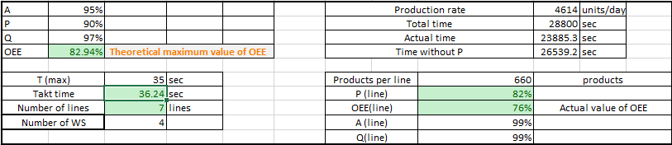***Takt time = 36.24 sec***

*After Takt time evaluation, we can find Performance index of each Workstation and therefore find Performance index of the line. To find Performance index of each workstation we have to find production rate per line (PRL) and Actual time without performance index:*

* *PRL = Actual time / Takt time = 660 units/day*
* *Actual time without P = Total time* Availability * Quality = 26539.2 sec*

*Performance index per workstation [P(Ws)]:*

* *P(Ws) = Production rate per line * Workstation time / Actual time without P*

*Performance index of the line is equal to average of Workstation Performance Indexes:*

* *P(line)= (P(Ws1)+P(Ws2)+P(Ws3)+P(Ws4)) / 4*
* ***P(line) = 82%***

*After P(line) evaluation we can find Actual Value of OEE:*

* ***OEE(actual value) = Availability * Quality * P(line) = 76%***

*The layout of a line can make quite a difference in the performance of the line Among the different possibilities to arrange our plant layout, a straight line has been chosen against u-line.*

*A straight line is more suitable short lines, the advantage is easy access from both sides for both material and operators, length of the line must be taken into count to avoid reaching limits of the building.*

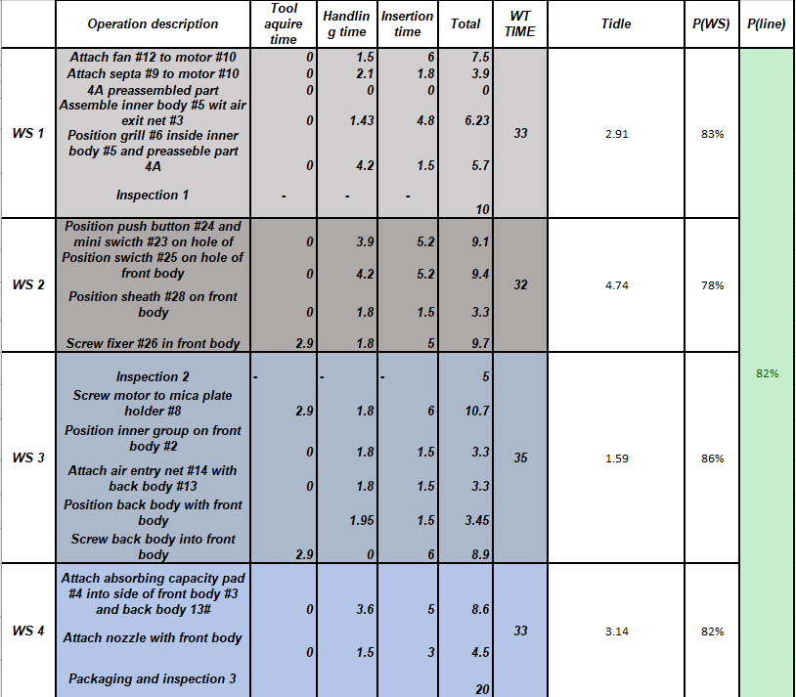

1. ***RAZOR***

***Calculation of takt time with number of lines and workstations***

*One 8-hour shift per day:* ***28800 seconds/day***

*Production demand:* ***9843 units/day***

*Total cycle time to assemble one product:* ***104.29s***

|  |  |
| --- | --- |
| *Availability* | *95%* |
| *Permorfamce Index* | *90%* |
| *Quality Rate* | *97%* |

*Availability of assembly lines due to failures and/or maintenance of*

*Quality rate considering 3% scrap rate.*

*Figure 6.1*

*Thus, theoretical overall equipment effectiveness of assembling process is,*

|  |  |
| --- | --- |
| *Operation* | *Cyc. Time (s)* |
| *SA-1* | *14* |
| *A-1* | *17.05* |
| *SA-2* | *9.45* |
| *A-2* | *8.3* |
| *A-3* | *15.1* |
| *A-4* | *2* |
| *SA-3* | *19.29* |
| *A-5* | *3.75* |
| *A-6* | *13.35* |
| *A-7* | *2* |

***Theoretical OEE =*** *95% x 90% x 97%* ***= 82.94%***

***Actual available time = 28800 x OEE***

***Takt time = $\frac{Actual available time}{Product demand}$ = 2.43s***

*Takt time of 2.43s is less than maximum cycle time of operations, which is 19.29s for operation SA-3*

* *Parallel assembly lines are the solution.*

*Parallel lines will have to satisfy theoretical minimum number of workstations required,*

$Theoretical\min{no of workstation= \frac{Total cycle time}{Takt time}=42.98 ( Taken 43)}$

|  |  |  |  |  |
| --- | --- | --- | --- | --- |
| **1st choice , no. of lines** |  |  | **7** |  |
| **new takt time** |  |  | **16.98638** | **(Not acceptable)** |
| **2nd choice , no. of lines** |  |  | **8** |  |
| **new takt time** |  |  | **19.41301** | **(Doable)** |
| **3rd choice ,no. of lines** |  |  | **9** |  |
| **new takt time** |  |  | **21.83963** | **(will be more idle time)** |

*Table 6.2*

***Assembly plant will require minimum 8 parallel assembly lines to meet the product’s demand.***

*Calculations with more than 8 lines (including 10,11, 12,…,16) had no better yield than having 8 lines. 8 lines are more feasible.*

*Following, we take* ***19.413s*** *as* ***Workstation cycle time****.*

***Workstation Task Assignment***

*A look at the assembly process flow gives us the following predecessors data,*

|  |  |
| --- | --- |
| OP | Predecessors |
| SA1 | - |
| A1 | SA1 |
| SA2 | - |
| A2 | A1, SA2 |
| A3 | A2 |
| A4 | A3 |
| SA3 | - |
| A5 | A4, SA3 |
| A6 | A5 |
| A7 | A6 |

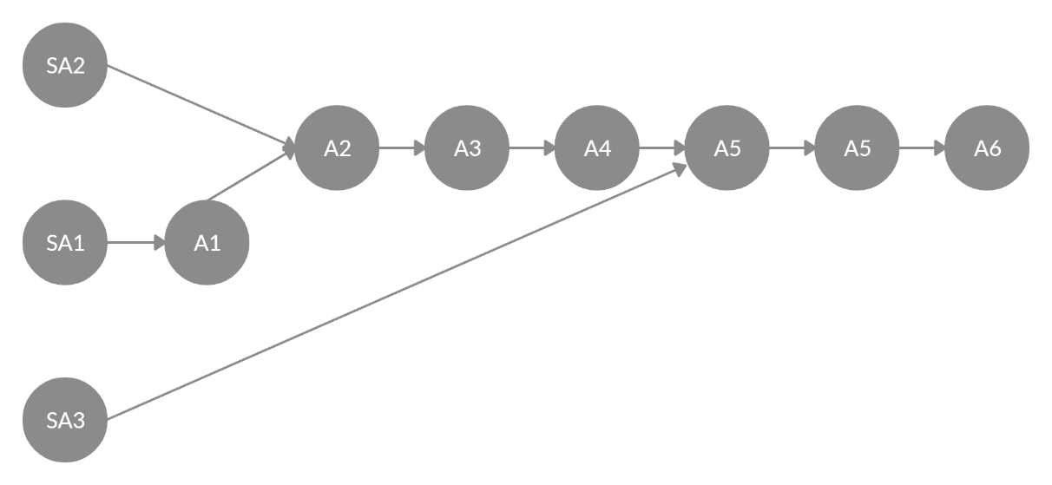

precedence diagram

*Figure 6.2*

***Ranked Positional Weight Technique (RPWT)*** *has been used to determine the Ranked positional weight of each operation*

*A strong computational comparison of both Straight line and U-line showed the task assignment in U-line showed better equal distribution of the work.*

|  |  |  |  |  |  |
| --- | --- | --- | --- | --- | --- |
| Operation | Cyc. Time (s) | PW(F) | RPW(F) | PW(B) | RPW(B) |
| SA-1 | 14 | 75.55 | 1 | 14 | 10 |
| A-1 | 17.05 | 61.55 | 2 | 31.05 | 7 |
| SA-2 | 9.45 | 53.95 | 3 | 9.45 | 9 |
| A-2 | 8.3 | 44.5 | 4 | 48.8 | 6 |
| A-3 | 15.1 | 36.2 | 6 | 63.9 | 5 |
| A-4 | 2 | 21.1 | 7 | 65.9 | 4 |
| SA-3 | 19.29 | 38.39 | 5 | 19.29 | 8 |
| A-5 | 3.75 | 19.1 | 8 | 88.94 | 3 |
| A-6 | 13.35 | 15.35 | 9 | 102.29 | 2 |
| A-7 | 2 | 2 | 10 | 104.29 | 1 |

*Table 6.2 shows positional weights forward as well as backwards, and based on that, Ranked positional weight of each operation.*

*With above obtained RPW and the Workstation cycle time of* ***19.413s****, with* ***8 assembly lines*** *also keeping mind the minimum theoretical number of workstations require* ***43****,*

|  |  |  |  |  |  |
| --- | --- | --- | --- | --- | --- |
| Ops | Cycle time (s) | Workstation | WS cycle time (s) | Idle time (s) | P (WS) |
| SA-1 | 14 | 1 |  |  |  |
| A-7 | 2 | 1 | 16 | 3.413008229 | 74% |
| A-1 | 17.05 | 2 | 17.05 | 2.363008229 | 79% |
| SA-2 | 9.45 | 3 |  |  |  |
| A-2 | 8.3 | 3 | 17.75 | 1.663008229 | 82% |
| SA-3 | 19.29 | 4 | 19.29 | 0.123008229 | 89% |
| A-3 | 15.1 | 5 |  |  |  |
| A-4 | 2 | 5 | 17.1 | 2.313008229 | 79% |
| A-5 | 3.75 | 6 |  |  |  |
| A-6 | 13.35 | 6 | 17.1 | 2.313008229 | 79% |
|  | | | | | |
|  | total workstations | 6 | total idle time | 12.18804938 | AVG 81% |

*Table 6.3*

*Compared with straight line assignment where Workstation 1 has more idle time, here in U-line assignment, it shows more equally distributed workload.*

*Workstations assigned based on the above obtained data,*

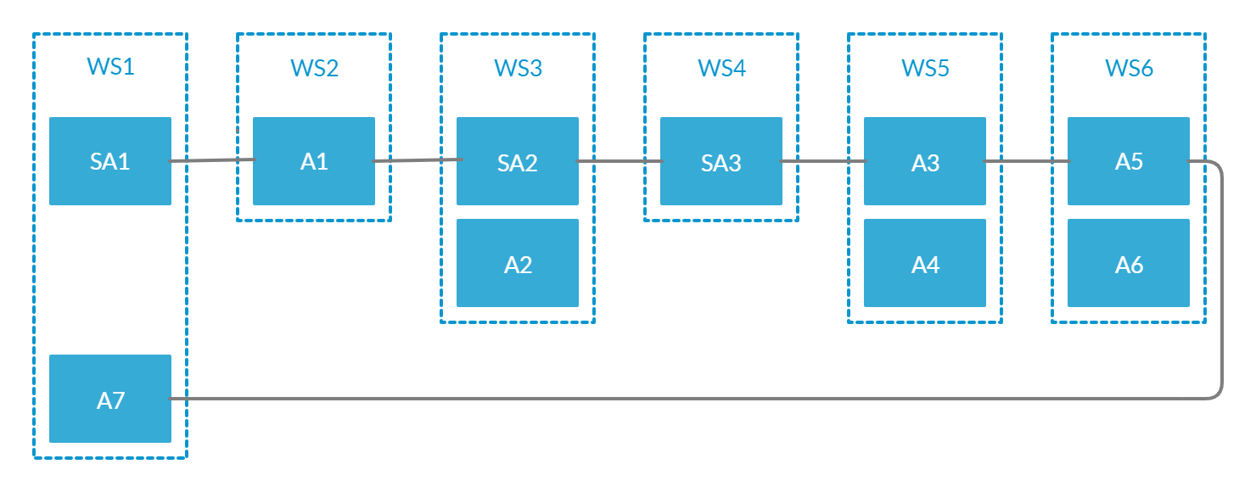

*Figure 6.3 Workstation-tasks assignment*

* *With 8 assembly lines and 6 workstations on each line, total of* ***48 workstations***

*48 > 43, theoretical min number of workstations required, checked!*

* *For Line Performance Index, taken the average of all the workstations’ performance which comes out as* ***81%***
* *with Quality rate 97%, Availability 95%, and Line Performance index 81%*

***Actual OEE of the line = 74%***

*Theoretical OEE = 82.94%*

*After line balancing, the actual OEE of the line designed, 74%, is quite feasibly comparable to the theoretically obtained OEE, 82.94%*

* ***Plant Design Efficiency = $\frac{sum of task times}{no of WS x WS cyle time}$ = 90%***

*After line balancing, obtained 90% efficiency of the plant design is also a green signal to the layout.*

1. *Defining the block Layout*
2. ***HAIRDRYER***

***Block Diagram of Production Lines***

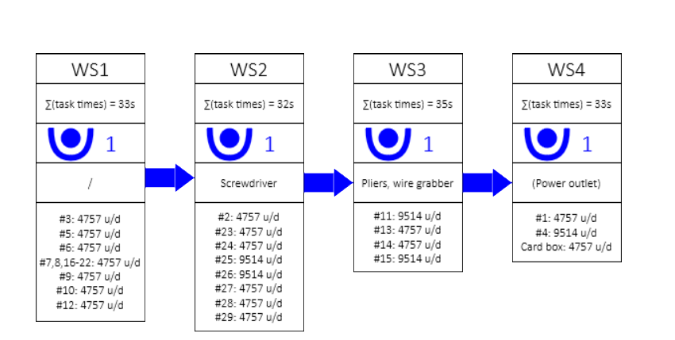 *As it was previously identified, in order to improve Overall Equivalent Efficiency (OEE) and reduce overload on some stations, we increased number of Workstations from two to four. As the result, we have a balanced production line and operation time in workstations is almost equal:*

* ***Workstation 1 (WS1)***

*In the first workstation we assembly internal part of the hair dryer, and we have a total task time equal to 33 seconds. As number of operations and raw materials reduced, we can assign only one worker to the workstation. List of raw materials: air-exit net, motor, inner body, preassembled part, grill, fan. We also have a first inspection, which is crucial for our production system*

* ***Workstation 2 (WS2)***

*After assembling internal part of the hair dryer, in the second Workstation we screw front part, which consist of front body, mini switch, push button, switch, screw type 3, fixer, sheath and power plug. Number of workers we keep equal to one and total task time is 32 seconds. We provide our workers with automatic screwdriver to improve working efficiency and time management.*

* ***Workstation 3 (WS3)***

*In the third workstation we add assemble back body with front body. Due complicated operations total task time increased to 35 seconds. Nevertheless, we have only one worker and lower number of raw materials (screw type two, screw type one, back body, air entrance). To make operations we use pliers and wire grabber. In the end we make second inspection to guarantee quality*

* ***Workstation 4 (WS4)***

*In the last workstation we have are finishing hairdryer assembly and make final inspection and packaging. Number of workers is the same as in previous workstation. However, task time reduced to 33 seconds. We don’t have many raw materials, only nozzle and absorbing capacity pad. We also have card boxes that we use to transport our finished product to finished product warehouse*

* ***Total task time***

*As we increased number of workstations, we have a higher total task time. Currently, it takes* ***133 seconds*** *to produce one hairdryer from the beginning. Nevertheless, efficiency increased and number of lines reduced, as now we have balanced line and task time split between workstations is almost equal.*

***Storage, production lines and transportation:***

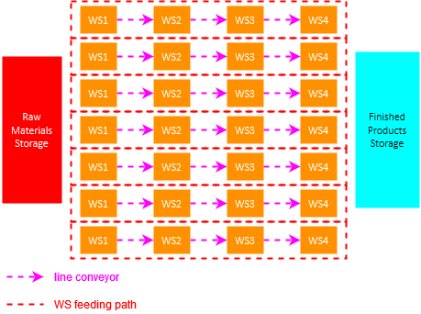

***B. RAZOR***

*Block layout of a production line*

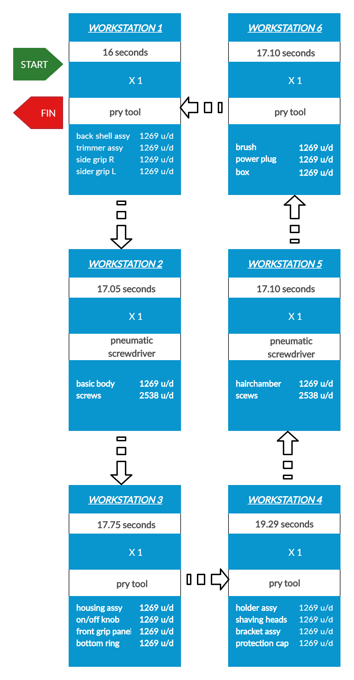

*We implement the proposed U-line layout of our assembly line with employing the lean manufacturing principles namely 5s, Kaizen (continuous improvement) and visual management and ergonomics.*





*WS1 – operates task SA1 and feeds further to WS2, WS6 returns the packaged box to WS1 which undergoes quality check and labels the pack and places it on the conveyor which then travels to the packaging area.*

*WS2 – Operator completes task A1 and passes the assembly to WS3.*

*WS3 – Operator completes tasks SA2 and A2 and passes the assembly to WS4.*

*WS4 – Assembles the head sub-assy and places it in the assembly holder.*

*WS5 – Operator performs tasks A3 and A4 (visual check).*

*WS6 – Tasks A5 and A6 are completed, operator returns the boxed product to WS1.*

|  |  |  |  |  |
| --- | --- | --- | --- | --- |
| *WS* | *Ops* | *Raw Materials* | *Consumption (u/d)* | *Tools* |
| *1* | *SA-1, A7* | *Back shell assy* | *1269* | *pry tool* |
| *Trimmer assy* | *1269* |
| *Side grip L* | *1269* |
| *Side grip R* | *1269* |
| *2* | *A-1* | *Basic body* | *1269* | *Pneumatic screwdriver* |
| *Screws* | *2538* |
| *3* | *SA2, A2* | *Housing assy* | *1269* | *pry tool* |
| *On/Off knob* | *1269* |
| *Front grip panel* | *1269* |
| *Bottom ring* | *1269* |
| *4* | *SA3* | *Holder assy* | *1269* | *pry tool* |
| *Shaving Head* | *1269* |
| *Bracket assy* | *1269* |
| *Protection cap* | *1269* |
| *5* | *A3, A4* | *Hairchamber* | *1269* | *Pneumatic screwdriver* |
| *Screws* | *2538* |
| *6* | *A5, A6* | *Brush* | *1269* | *pry tool* |
| *Power Plug* | *1269* |
| *Cardboard box* | *1269* |

***Total Workstation Cycle Times –***

*The cycle times for each workstation is reported in table 7.1 by calculations based in section 6.*

***Number of workers –***

*As the total workstation cycle time for all the workstations is less than the takt time, one operator is assigned for each workstation to perform the tasks.*

***Tools at Workstations –***

*Operators at WS2 and WS5 perform screw fastening operations, the workstations are equipped with industrial grade pneumatic screwdrivers providing precision and quick operation. Remaining workstations do not perform any tasks requiring tools, but all stations are equipped with pry tools to allow easier disassembly if need be in rare cases.*

**

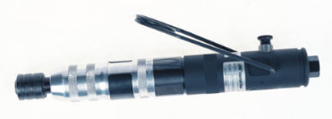

*Pneumatic screwdriver*

*Pry tool*

***Raw Materials and consumption –***

*Raw materials are calculated on based of demand per line per day for each workstation corresponding to performed tasks as reported in table 7.1*

***Assembly movement in production line****:*

*Given the fact that we implement the U-line methodology, we configure this setup dedicated more to our specific needs, factors influencing to design this layout,*

* *Only WS1 operates task from the start (SA1) and from the end (A7), it is pertinent that the assembly returns to WS1 .*
* *Whereas, rest of the workstations follow a simpler path wherein they receive assembly from the previous workstation and feed it to the next.*
* *The assembly is moved in an* ***assembly holder*** *1(figure 7.2) from workstation to workstation.*
* *As our assembly is small and light, as well as there is no distance between workstations, it is conferred there is no need of an automated material transfer system inside a production line, saving set up cost and time.*
* *Operators can be seated or standing, receive “work-on” assembly holder from a designated area at one end of the table and pass “worked on” assembly holder to the next workstation manually by placing in designated area at the opposite end.*
* *At the end of the line in WS1, the operator labels the packaged razor and places it on the conveyor which is connected to other production lines as explained in part b.*

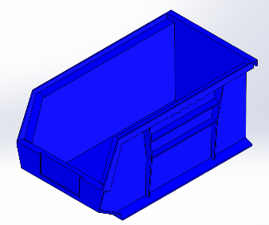

*Figure 7.2 – Assembly holder*

*1Assembly holders are used to move assemblies in between workstations.*

*Proposed schematic layout of razor production area*

*While designing a layout for the razor production area, focus is given on ways and techniques optimizing flow of material & information and reducing waste.*

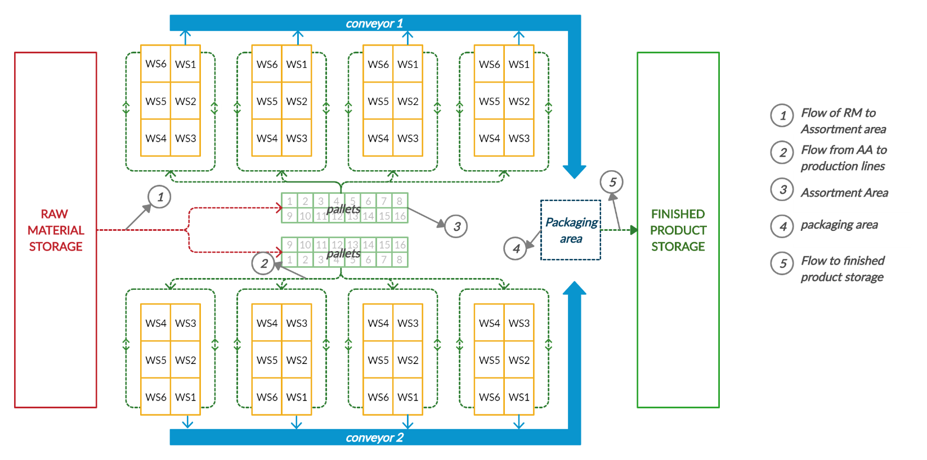

*Figure 7.2 – Razor production facility schematic layout*

* *Components arrive from RMS in palletized boxes following the route in red by means of a material handling system.*
* *Pallets are placed in marked areas designated for each raw component in the* ***Assortment Area****.*
* *An operator assigned at Assortment area fills* ***automated guided vehicle*** *according to the request received from workstation and moves the rack towards the workstation by following the path in green.*
* *The box or boxes of the component(s) is replaced by empty boxes from the* ***workstation storage racks****1.*
* *The boxed razor is placed on a conveyor system which also receives boxes from other production lines and arrives at* ***Packaging Area*** *where the boxes are packed in a master box which is then palletized.*
* *The master boxes are palletized and are transported to dedicated finished product storage by following the path in green.*

*The 8 production lines are divided in two equal opposite areas, with each section having dedicated assortment areas. The four production lines in both sections are connected with a material conveyor system which moves the boxed razors to a common packing area.*

*Benefits of implementing proposed layout are,*

* *As the number of parallel production lines is 8 it gives way to possible cluttering at workspaces if all lines were placed in single section, thus dividing them in two equal sections provides sufficient space for uncongested flow.*
* *This also allows us to reduce number of material transfer system by use of one conveyor system simultaneously for four production lines, saving cost and set up time.*
* *A dedicated Assortment area for each section reduces chances of clustering of corresponding component pallets at required workstation saving space. It also enables faster delivery of components to workstations.*
* *Furthermore, this eliminates traffic near production lines, a safety factor to be considered to reduce probability of accidents at production line.*
* *A common packing area reduces the distance and time to transport the palletized finished product also reducing cross traffic with RMS traffic.*

*1Workstation storage rack is explained in detail in section 8 – Workstation study.*

# *Study of workstation*

1. ***HAIRDRYER***

*To design a proper workstation, suitable for an employee, we have to take into account several factors provided by the standards of* ***ergonomics*** *– science of preventing musculoskeletal injuries in the workplace. We should remember that safety and health considerations are an integral part of the workstation design.*

*The workstation we consider is the first of our line, which is used to perform five operations mentioned above.*

*To start, we should consider a general anthropometric data so that our workstation will be comfortable for an average man or a woman. The reference worker’s height we take is 175 cm (average in Europe and in the world). The table will be designed for a standing work, but employees will be provided with an* ***adjustable chair*** *to provide maximum comfort. The option of working while standing or sitting gives the operator chance to move around and reduce the effects of fatigue.*

*Then, to design a table we need to find proper width, length and height. For the height, we refer to the term* ***correct work height****, which is the optimal value for a person to perform the manual job. This particular height helps keep forearm relatively straight and avoid bending (which may result in different types of wrist and elbow injuries). To find the correct work height a person stands straight with his forearm held parallel to the ground and the upper arm straight down, th0e distance from floor to elbow is measured. Considering a person of 175 cm height this value would be around 106 cm. With the work at this workstation being relatively light, we can set our table’s height to* ***109 cm*** *(for heavy work the correct work height should be 5 cm below the elbow height).*

*Next, the table’s width and length should allow the operator to work comfortably and do not restrict any hand motions yet allowing for all the need tools to be placed as close to the point of use as possible. The suggested length of 2 m and width of 1 m are good numbers.*

*Location of parts and tools is an important factor as well. All the objects to be used should be placed so that we are able to free the hands from as much work as possible. The farther we reach for something, the more costly and fatiguing that reach will be. The* ***arm reach distance*** *is defined as a distance at which the hand would be in the most relaxed position while reaching for an object. It is approximately equal to the distance from upper arm to the tip of the thumb of a straight hand. The value is around 63 cm for men and 58 cm for women. The average of 60 cm is a good estimation for our design.*

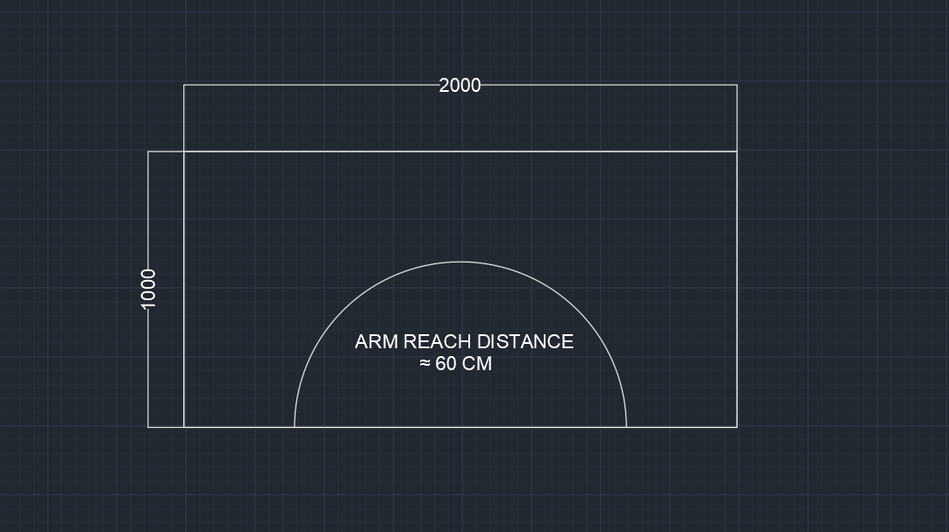

*All the objects should be placed at least on the edge of that radius.*

*To maximize our operator’s efficiency, his hand motions should be mirrored to each other and be both equally busy during the work. Taking into account that we exploit 8 types of parts from 8 containers, positioning two stand shelves with four containers in each within 120° area would bring us closer to the ideal case. The containers will be placed so that hand motions are mirrored (for example, container with fans and container with motors will be inside two opposite stands, so that operator can reach for them simultaneously in the opposite ways).*

*The stands with shelves will have two levels: containing two containers on the each. Moreover, the upper shelve will be 30° inclined to ease the reaching for the distant parts yet maximizing the use of gravity (one of the principles of ergonomics).*

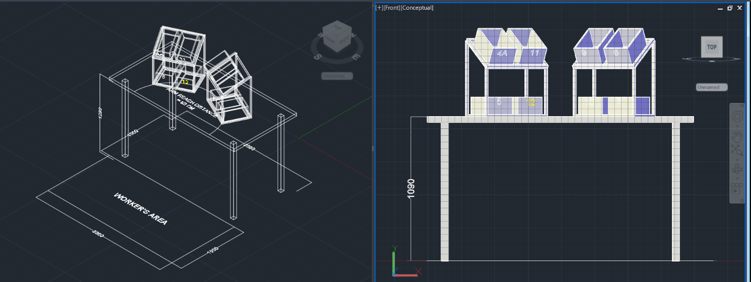

*Since one of our goals is to reduce hand motion is much as possible, for tasks that require connection with screws or attaching one part to another we will use the vise (any other type of fixtures or jigs can be also used). This vise will be placed approximately in the upper part of the arm reach radius so that operator can fix the part in there and using the pneumatic screwdriver join the parts.*

*Operator’s area should be spacious enough to place the adjustable chair and provide unrestricted motion between roller conveyor and the table, 2 m by 1 m is chosen.*

*The roller conveyor dimensions are approximate and primarily depend on the model. Here, the model with size 837 x 2574 x 898 is taken as an example.*

*Below, the complete view of the workstation is provided along with the bill of materials.*

HAIRDRYER WORKSTATION

1. ***RAZOR***

*The razor workstation has been designed to satisfy all the ergonomics and keeping the cost low.* *An ergonomic workstation facilitates work and maintains good employee health. The results: Increased motivation and satisfaction, higher performance, efficiency, and processing quality, as well as fewer absences due to illness.*

*The bottom line: Ergonomics provide you with valuable benefits in the form of higher productivity, increased efficiency, and a decisive edge over the competition – thus ensuring lasting success for your company.*

# *The workstation*

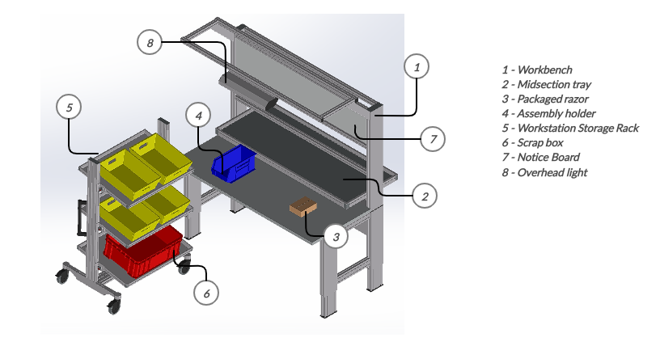

*Figure 8.1 – Workstation Area*

*Detailed insight –*

* *The* ***Workbench height*** *follows standards set for an optimal productivity and is set for height of an average operator; the work area is below heart level to promote blood circulation. The workstation is also equipped with height adjustable chair to allow options for sit-down/stand-up type.*
* ***Reach zone*** *of the bench is set to allow good motor skills, and to avoid operators experiencing carpal tunnel syndrome by placing component containers at optimal reach. All container, equipment’s and operating elements are accessible and arranged in anatomic /physiological range of movement for the employee.*
* *The sub-assembly components are placed in workstation storage rack as displayed in figure 8.1, the WSR is placed close to the operator for ease of access. The inclined storage is more accessible to the operator at shoulder level to reduce bending movement.*
* *The workstation is* ***equipped with lighting*** *to avoid stress to the operator’s eyes, as well as a* ***notice board*** *section to provide useful information about the tasks, quality standards and other critical information.*
* *The* ***mid-section tray*** *is used by operator at WS6 to place the complete packaged razor box, which the operator at WS1 collects and performs quality check and labels the box if passed.*

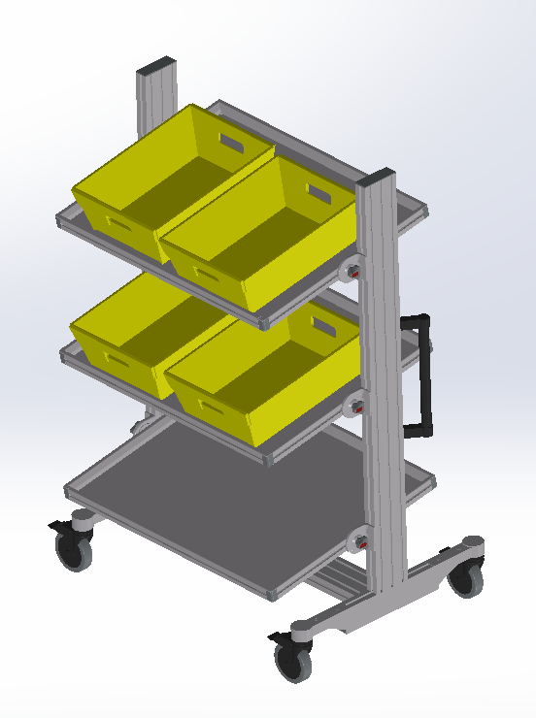***Workstation Storage Rack –***

*The workstation is equipped with a WSR to store all the sub-assembly components for WS1. The WSR features three level sections with the top two sections to store boxes of components, whereas the last level is for scrap box.*

*The levels are maintained such to provide ease of access for the operator. It is also equipped with wheels to allow operator to move the trolley according to their needs.*

***RAZOR Workstation 1 Area Layout :***

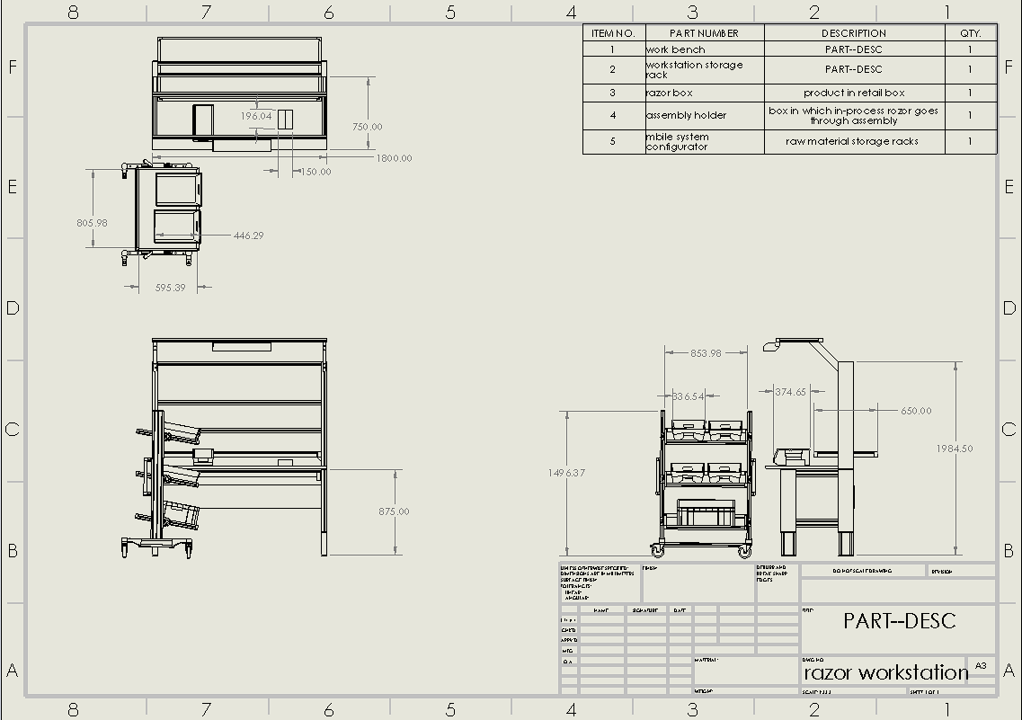

1. *Definition of LU for RMS*

***A. Hairdryer***

*Before defining the load unit and shifting attention to further analyses, a number of considerations have to be made, such as looking into how heavy the odette box would become upon being filled with the maximum quantity of raw material. To do this, the volume of each raw material was estimated from the hairdryer’s exploded view, and the weight was computed in reverse from an approximate of the fully assembled hairdryer weight (750g). This figure was obtained from looking at the weight of hairdryers of similar size, and the weight of each raw material was computed with the kind of material said RM was constituted by (plastic/steel/etc).*

*Finding the weight of each raw material, the weight of the odette boxes filled with them was calculated. In this step, the weight of the box in question was added to the calculation (600g for odette 1 and 4020 for odette 3) in order to draw closer to the real weight.*

*After finishing this calculation, it is possible to see which raw materials are under a weight constraint more than a spatial constraint*[1]*. Thanks to this, the load unit can be easily defined (for both transport to the assembly line and raw material storage). This process is outlined futher.*

*The Load Unit we chose for the warehouse is the EUR 2 pallet, that is, the complete volume available on the surface (taking into account the max height of 2100mm with pallet and 1250kg weight limit). Trucks (to be further discussed in Task 11 and 12) will deliver these Load Units, and then through the picking area will be placed on the pallet racks.*

*The Load Units for feeding the workstations are defined to be the* ***odette boxes****. From the raw material storage, the forklift trucks bring to the picking area the weekly demand of these boxes* ***for each component for every line****. Whenever the odette boxes of either component are close to lacking, the supply is repeated. Considering that the odette boxes are occupying not so much space, this approach seems to be the most convenient, it allows flexibility and helps to utilize the available space better. Hence, the Inventory Curve for workstation feed is going to be smooth with xoincident refilling days (provided in sec. 10).*

*Table 1 of the Appendix A summarizes all the data regarding capacities and pallets.*

1. ***Razor***

*Flow of components in razor production consists of receiving components in* ***single coded pallets*** *from manufacturer and are stored in RMS on pallet racks. Single coded pallets are then transported to a picking area where* ***the load unit is converted from Pallets to Odette boxes*** *to feed the workstations.*

*To define the LU for each part (i.e from receiving to RMS and from picking area to WS), factors such as maximum weight limit for odette, weight limit for pallet, size of the components and NIOSH limit are considered. Weight of each component was approximated by weighing each component in assembly of a* ***Philips Aquatouch Razor AT620****. The number of components in each odette box was calculated with volumetric analysis and packing strategy. The weight of odette box is also considered while stacking on pallet.*



*Table 9b.1*

***Pallets are used as load units to manage warehouse****, the procured components are stored on* ***EURO pallet 2****, dimensions of which are reported in Table 9b.1 To efficiently make use of pallet racks, pallets are loaded considering the* ***maximum height limit of******2100mm*** *(load + pallet height) and a* ***maximum safety working load of 1250kg****.*

*The pallets are then moved to the* ***picking area*** *near razor production lines and are placed in pre-marked areas on ground, enough clearance is provided for FLT movement, to avoid cluster and increase safety****. A picking area operator converts the arrived load unit (pallet) to odette*** *for feeding the workstations by placing different codes odette as per demand on* ***AGVs****1 which carry them to each workstations.*

*Finally, we obtain the SAC – Storage Analysis Chart for the razor production reported in table 9b.2*

|  |  |  |  |  |  |  |  |  |  |  |  |  |  |  |
| --- | --- | --- | --- | --- | --- | --- | --- | --- | --- | --- | --- | --- | --- | --- |
| ***Code*** | ***Desc.*** | ***Wt. of comp. (g)*** | ***Unit Load*** | | | | | ***Quantity*** | | | ***Material Handling*** | | | |
| ***Type*** | ***Capacity (pcs)*** | ***Size (mm)*** | ***Wt.***  ***Odette***  ***(kg)*** | ***Wt.***  ***pallet (kg)*** | ***Max*** | ***Avg.*** | ***Method*** | ***Spec.(mm)*** | ***Area (sqm)*** | ***Class*** |
| 1 | protecting cap | 15.0 | EUR pallet 2 | 54272 | 1200x1000 x1917.5(h) | 3.45 | 883 | 3 | 1.5 | pallet rack | 1300x1100 x2017.5(h) | 1.43 | ***B*** |
| 2 | bracket assy | 10.0 | EUR pallet 2 | 27136 | 1200x1000 x1917.5(h) | 1.61 | 412 | 6 | 3 | pallet rack | 1300x1100 x2017.5(h) | 1.43 | ***A*** |
| 3 | Power plug | 100.0 | EUR pallet 2 | 10240 | 1200x1000 x1917.5(h) | 5.20 | 1331 | 15 | 7.5 | pallet rack | 1300x1100 x2017.5(h) | 1.43 | ***A*** |
| 4 | Shaving head | 8.0 | EUR pallet 2 | 54272 | 1200x1000 x1917.5(h) | 2.25 | 575 | 3 | 1.5 | pallet rack | 1300x1100 x2017.5(h) | 1.43 | ***B*** |
| 5 | Holder assy | 4.0 | EUR pallet 2 | 81408 | 1200x1000 x1917.5(h) | 1.75 | 447 | 2 | 1 | pallet rack | 1300x1100 x2017.5(h) | 1.43 | ***B*** |
| 6 | Hair  chamber | 8.0 | EUR pallet 2 | 27136 | 1200x1000 x1917.5(h) | 1.41 | 360 | 6 | 3 | pallet rack | 1300x1100 x2017.5(h) | 1.43 | ***A*** |
| 7 | Basic Body | 100.0 | EUR pallet 2 | 6800 | 1200x1000 x1760(h) | 9.44 | 755 | 23 | 11.5 | pallet rack | 1300x1100 x2017.5(h) | 1.43 | ***A*** |
| 8 | Front grip pannel | 4.0 | EUR pallet 2 | 54272 | 1200x1000 x1917.5(h) | 1.32 | 337 | 3 | 1.5 | pallet rack | 1300x1100 x2017.5(h) | 1.43 | ***B*** |
| 9 | On/Off knob | 2.0 | EUR pallet 2 | 152280 | 1200x1000 x885(h) | 3.67 | 440 | 1 | 0.5 | pallet rack | 1300x1100 x2017.5(h) | 1.43 | ***C*** |
| 10 | Housing assy | 23.0 | EUR pallet 2 | 10240 | 1200x1000 x1917.5(h) | 1.06 | 271 | 15 | 7.5 | pallet rack | 1300x1100 x2017.5(h) | 1.43 | ***A*** |
| 11 | Bottom ring | 2.0 | EUR pallet 2 | 152280 | 1200x1000 x885(h) | 4.69 | 563 | 1 | 0.5 | pallet rack | 1300x1100 x2017.5(h) | 1.43 | ***C*** |
| 12 | Brush | 4.0 | EUR pallet 2 | 152400 | 1200x1000 x1917.5(h) | 3.05 | 732 | 1 | 0.5 | pallet rack | 1300x1100 x2017.5(h) | 1.43 | ***C*** |
| 13 | Trimmer assy | 4.0 | EUR pallet 2 | 152280 | 1200x1000 x885(h) | 4.35 | 522 | 1 | 0.5 | pallet rack | 1300x1100 x2017.5(h) | 1.43 | ***C*** |
| 14 A | Side grips R | 9.0 | EUR pallet 2 | 108288 | 1200x1000 x1917.5(h) | 3.78 | 967 | 2 | 1 | pallet rack | 1300x1100 x2017.5(h) | 1.43 | ***B*** |
| 14 B | Side grips L | 9.0 | EUR pallet 2 | 108288 | 1200x1000 x1917.5(h) | 3.78 | 967 | 2 | 1 | pallet rack | 1300x1100 x2017.5(h) | 1.43 | ***B*** |
| 15 | Back shell assy | 16.0 | EUR pallet 2 | 15616 | 1200x1000 x1917.5(h) | 1.27 | 326 | 10 | 5 | pallet rack | 1300x1100 x2017.5(h) | 1.43 | ***A*** |
| 16 | Screw* | 0.5 | EUR pallet 2 | 625000 | 1200x1000 x147.5(h) | 156.25 | 1250 | 1 | 0.5 | pallet rack | 1300x1100 x2017.5(h) | 1.43 | ***C*** |

*Table 9b.2 – SAC (Storage Analysis Chart) – Razor*

1. *Raw Material Flows*
   1. ***Inventories and flow***

*A* ***product-oriented*** *storage philosophy is followed to manage the warehouse of the plant with* ***fixed allocation criteria*** *and* ***replenishment cycle of 15 days*** *for both products where the peak inventory is the sum of peak inventories for each code.*

1. ***Hairdryer***

*After defining* ***that one Load Unit = one pallet*** *and calculating required consumption of Load Units of raw material per week, we have to group our raw materials to define supply days for our warehouse to keep production flow smooth and without any failures or material shortages.*

*There are two ways to manage our supply scheme:*

* ***From Economic Point of View***
* ***Raw Materials Approach***

***It should mentioned that due to the constraint we have (15 days peak inventory for each raw material), we are forced to opt for the second approach, which we utilized eventually. Nevertheless, we will discuss both of them.***

***Economical Point of View***

*It is clear, that keeping expensive components in the warehouse costs much more than maintaining cheaper parts. In order to maximize efficiency of our production line from the economic point of view, it will be wiser not to have a big number of costly components in our warehouse for a long time. We can use* ***Pareto’s principle*** *to sort our raw materials from Economic point of view. According to the theorem 20 % (roughly) of the components make 80% of the final product value, and we have to define these components.*



*On the horizontal axis, all the components of the hairdryer are represented (10 components of the preassembly are represented as one component). On the vertical – the components’ prices stored weekly and percent of the total cost respectively.*

*From the table it is clear that considering week demand and product price, we can define a range of components, which effect is the most sensible for the final value. Therefore, we can sort our components into 3 classes, following the* ***ABC analysis****:*

* ***A Class***

*In this group we included the most important and expensive components. From the Pareto’s chart above, we can see that they make around 80% of the final value, according to the principle. These components are: motor, preassembly, septa, front body, back body, inner body, fan, power plug.*

* ***B Class***

*In the Group B, we have components, which total effect on the final price do not exceed 15 -18 %, which are: nozzle, mini switch, grill, fixer, absorbing capacity pad, switch, sheath and air-exit net.*

* ***C Class***

*The last group of materials and their combined effect is less than 5%, which are: all types of screws, air-entrance, push button.*

*The Table 1 in Appendix A summarizes the classification.*

*The prices of all components are based on the average market prices, so that the total selling price of the hairdryer is around $39. We can see that weekly demand of all the components adds up to* ***$971 019****.*

*If we keep the three weeks (15 working days) inventory, then this value would be $2 913 057 ($971 019 x 3). A carrying cost of 25 percent per year is normal, so the cost of carrying a three-week supply of inventory is* ***$728 264 per year****.*

*If we redesign the system according to ABC method, where A class components would be kept for 1 week, B class for 2 weeks and C class for 3 weeks, we could save* ***$422 903*** *of the carrying cost per year!*

**

ABC and Regular methods comparison

*Since we have a restriction of 15-day peak inventory for each class, we have to modify our supply system. After defining classes of raw materials, we have to find 3-week demand in LU for our production, as we are going to receive our components every 3 weeks (15 working days).*

*So for Class:*

***A = 117 LU / 3 weeks***

***B = 39 LU/ 3 weeks***

***C = 15 LU/ 3 weeks***



*Now, we can define days we receive our raw materials.*

* *To choose receiving days we firstly have to find* ***daily demand in LU per class***

***Class A = 7.8 LU/day***

***Class B = 2.6 LU/day***

***Class C = 1 LU/day***

*After defining consumption rate per class, we can find a day when we will have the least number of LU per class in our warehouse. Priority is given to Class A materials, because as we mentioned before their storing cost influences the most our budget. In addition, we have to consider that we can get raw materials only 2 days/ week.*

*Day 0 is the Monday’s morning; days 1, 2, 3, 4, 5 are Monday, Tuesday, Wednesday, Thursday and Friday respectively.*

*The values in the cells are the amounts of pallets* ***left by the end of the working day.***

*Table 2 of appendix A summarizes the inventory flow. The orange, yellow and red cells are the receiving days of each class.*

*From that table we can find out the most suitable receiving days for each class. The three-week demand of classes A and B is better to be received during the days which are close to each other, since storing the inventory costs money we wish to have least number of raw materials left in the warehouse in the receiving day. Class C can be received a week earlier as it does not affect much on our budget.*

***Class A = Thursday***

***Class B = Tuesday***

***Class C = Friday (different week)***

*In this case, we will have* ***Peak inventory equal to 182.4 LU (Pallets).***

**

***This is the best inventory management for this approach. However, as it can be seen, the problem with this is approach is that we receive very different amount of pallets of each class at once (117 for class A, 39 for B, and 15 for C), so the workload is not evenly distributed. This cannot be avoided since we have a constraint of 15-day peak inventory, which has to be considered. Thus, let us consider the Raw Material approach.***

***Raw Materials Point of View***

*Raw materials approach is based on the idea of creating* ***four groups of components*** *and having equal (or close) number of Load Units of each group to be received.*

**

**

*By sorting parts, which range in LU demand is high we were able to specify four different groups:*

* ***Group 1 = 48 LU/ 3 weeks***
* ***Group 2 = 42 LU/ 3 weeks***
* ***Group 3 = 39 LU/ 3 weeks***
* ***Group 4 = 42 LU / 3 weeks***

*As in the previous case, we have to define daily demand of each group to identify the most comfortable day of receiving materials:*

* ***Group 1 = 3.2 LU / day***
* ***Group 2 = 2.8 LU / day***
* ***Group 3 = 2.6 LU/ day***
* ***Group 4 = 2.8 LU/day***

*It is obvious from the calculation that now our groups are balanced and we will not have an overload in either of the groups. That is a better option from organizing point of view, as our workers will have balanced weeks and no rises and falls in supply as in previous case*

*In this approach, the best solution will be receiving two groups in one day and two other groups in another. Therefore, it is better to choose days in the same week, but with a day or two days difference in order not to have an overload for our workers. In addition, it has to be a week when we will have run out of our previous 3 weeks supply.*

* ***Group 1 & 2 = Monday***
* ***Group 3 & 4 = Thursday***

***In this approach, our Peak Inventory will be 194 Load Units (Pallets).***

*The summarizing table – Table 3 is provided in the appendix A. Orange cells are the receiving days, and as previously, each cell representing the remaining amount of pallets by the end of the day.*



*Now, the workload of the receiving days is balanced but the storage cost of the total inventory would be expectedly higher.*

***Conclusion:*** *the Economical approach would be the best option had not we had a constraint of 15-day peak inventory; this would allow us to greatly reduce the cost of storing all the raw materials and the workload of the receiving days would be evenly distributed.*

*Thus, we have chosen the* ***Raw Material approach*** *keeping in mind the priority of that constraint. The workload is now balanced and we can proceed further with the warehouse design.*

*The Inventory curve for the workstations was described in section 9 and is provided below, with each line representing each component of the hairdryer.*

**

1. ***Razor***

*The* ***peak inventory for Razor is******95 LU (pallets)*** *which amounts to* ***18848 odettes****. The number of odette per pallet is adjusted keeping in mind to feed 8 production lines efficiently with least amount of over stocking at picking area. Fig. 10b.1 is a graphical representation of data from* ***Table 1 in appendix B,*** *it shows the flow of LU through the RMS, replenishment cycle of 15 days is observed for each code and peaks correspond to receiving days. The maximum handling capacity for outgoing cycle* ***HCout is 2.25 LU/h*** *corresponds to flow of pallets to picking area as per demand* ***on refill days****.*

*Figure 10b.2 - represents the flow of odette boxes at picking area with peak inventory of* ***3600 odette boxes*** *(18 pallets). Data is obtained from* ***Table 2 in appendix B****. It is evident that every 15 days the ending inventory at picking area is zero, which correlates with the replenishing cycle. Each line represents feeding of respective component odette to respective workstations of each production line. The days corresponding to peaks are the refill days for respective code, filled pallets are ordered from the warehouse to picking-area.*

*We further analyze the inventory with Pareto’s Theorem and form the ABC curves and observe the 80%-20% rule.*

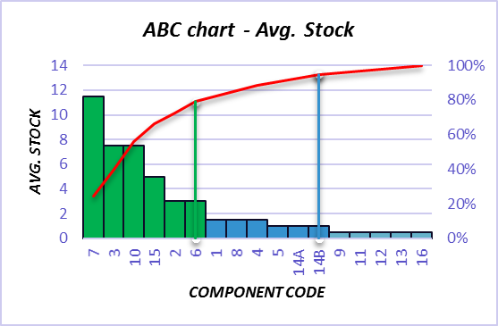

***A***

***B***

***C***

***80%***

***95%***

*Figure 10b.3*

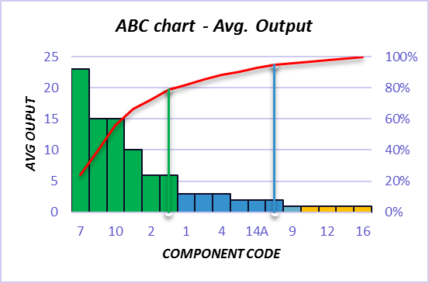

***A***

***B***

***C***

***80%***

***95%***

*Figure 10b.4*

*Figures 10b.3 & 10b.4 indicates the class-based analysis of the components.*

*Figure 10b.5 – ABC chart for avg output vs Avg. Stock follows a linear line thus confirming the product-oriented storage philosophy.*

*Figure 10b.5*

* 1. ***Planning of receiving items***

*The scheduling of receiving of components for both the products from manufacturers is planned to equally distribute the load on the material transport systems and the internal logistic workers. Delivery of components is* ***scheduled******for Mondays and Wednesdays of each week****.*

*It is assumed that the manufacturers for both the products are different and require different trucks for receiving.*

*The first and second week is slated for Razor components whereas the following third week is assigned for Hairdryer components. Detailed planning for each product is explained below.*

1. ***Hairdryer***

*The number of LU deliver at once for hairdryer department is 90 (81 for another day).*

*So, to satisfy the volume needed for that number of LU (approx. 221,40 m^3) we choose the truck of standard type having the characteristics given in the table before. We will need* ***3 trucks*** *of this type for each receiving day. *

|  |  |  |  |  |  |  |  |  |  |  |
| --- | --- | --- | --- | --- | --- | --- | --- | --- | --- | --- |
| ***Overall*** | | | ***Interior*** | | | ***Swing Doors*** | | ***Capacity*** | | ***Tare*** |
| Length | Width | Height | Length | Width | Height | Width | Height | Volume | | Weight |
| 13.7 m | 2.4 m | 13.56m | 12 m | 2.35 m | 2.55m | 2.34 m | 2.49 m | 81.35 | m3 | 5125 kg |

|  |  |  |  |
| --- | --- | --- | --- |
| ***Week*** | ***Day*** | ***Code*** | ***# pallets*** |
| *week n* | *mon* | *7* | *23* |
| *wed* | *1,2,3* | *24* |
| *week (n+1)* | *mon* | *4,6,10* | *24* |
| *wed* | *5,8,9,11,12,*  *13,14,15,16* | *24* |
|
| ***Total*** | | | ***95*** |

***B. Razor***

*Total number of load units to be delivered for razor is 95 LU, to equally distribute the load we receive approximately 24 LU per receiving day. Thus, handling capacity* ***HCin is******3 LU/h*** *for incoming cycle. Each code received on these days is reported in Table-10b.6 with corresponding weeks. Table 10b.6*

*To calculate number of delivery trucks, we consider the maximum load units (24LU) that will be delivered at once for production.*

*Volume of delivery – pallet vol. x no. of LU = 60 m3*

*No. of Trucks required – Vol. of delivery / Capacity of Truck ≈* ***1 Truck/day***

|  |  |  |  |  |  |  |  |  |  |  |
| --- | --- | --- | --- | --- | --- | --- | --- | --- | --- | --- |
| ***Overall*** | | | ***Interior*** | | | ***Swing Doors*** | | ***Capacity*** | | ***Tare*** |
| Length | Width | Height | Length | Width | Height | Width | Height | Volume | | Weight |
| 12.2 m | 2.4 m | 3.84 m | 12 m | 2.35 m | 2.4 m | 2.34 m | 2.34 m | 67.68 | m3 | 5125 kg |

*Razor Loading Truck specification*

1. *Raw Material Warehouse and Storage* 
   1. ***Static Sizing***

*A product-oriented storage system with fixed allocation criteria is followed, the Storage capacity of the warehouse is equal to the sum of peak inventories of both the products.*

*SC = 194 + 95 =* ***289 LU***

*As the storage capacity for the production is considerably small and as well the number of LU for each code is less, a* ***selective rack system*** *is used to provide the maximum* ***selectivity of 100%*** *and to optimize the space occupied. The load units are stored and retrieved by Forklift Trucks.*

***Location specification***

|  |  |  |  |  |  |  |  |
| --- | --- | --- | --- | --- | --- | --- | --- |
| ***Load Unit Size*** | | |  | ***Location Size*** | | | |
| *Length* | *1200* | *mm* |  | ***a*** | *Length* | ***1300*** | ***mm*** |
| *Width* | *1000* | *mm* |  | ***b*** | *Width* | ***1100*** | ***mm*** |
| *Height* | *1950* | *mm* |  | ***h*** | *Height* | ***2050*** | ***mm*** |

*To define the location size, we consider the dimensions of EURO pallet 2 with enough clearance of 100mm on both sides as well as height limit of 2100mm Table 11.1*

|  |  |  |
| --- | --- | --- |
| ***Forklift's Characteristics***  ***RX 60-25L/600/Li-ion*** | | |
| *Mast type* | *Triplex* | |
| *Lift height* | *7390* | mm |
| *Working aisle* | *1200* | mm |
| *Turning radius* | *2245* | mm |
| *Avg. travel speed* | *18* | km/h |
| *Avg. lifting speed* | *0.56* | m/s |
| *Avg. lowering speed* | *0.45* | m/s |

***Choice of Forklifts***

*Forklifts used for warehouse management – Still* [*RX 60-25L (Plus)/600|Li-Ion*](https://data.still.de/assets/products/Vehicles/Electric_Forklift_Trucks/RX_60_25-35_neu/pdfs/RX_60_25_35_EN_TD.pdf?mod=1586332037&download=1&s=b24cfe153980df9a3a7713dc9f2034c1)*. A high lift, counterbalanced forklift is chosen to perform the all the warehouse operations. Moreover, electric forklifts are chosen to have an ecological approach for production as well as reducing cost of operation as compared to conventional forklifts.*

*Table 11.2*

***Basic module***

*For a selective storage rack,*

|  |  |  |  |  |
| --- | --- | --- | --- | --- |
| ***b*** |  |  |  | ***b*** |
|
|  | ***a*** | ***c*** | ***a*** |  |

***Abm = b x (2a + c)***

*where,*

*a = length of location*

*b = width of location*

*c = working aisle width* Figure 11.1*

***Abm = 7.8 m2***

*\*Working aisle width is considered as turning diameter of the Forklift to provide ample space for FLTs to safely operate and turn b/w aisles*

***Number of levels;***

*Nlevel = int ( lift height/ h ) + 1, Therefore the* ***number of levels is 4.***

***Number of LU per module;***

*N(lu) = 2 x Nlevel* [LU], is **8 LU**

***Theoretical footprint;***

*alu = Abm /N(lu)* [m2/LU], *therefore* ***theoretical footprint is 0.97 m2/LU***

***Theoretical Storage area;***

*Asto,th = SC x alu , the theoretical* ***storage area required is 281.74 m2***

***Layout of warehouse***

|  |  |  |  |  |
| --- | --- | --- | --- | --- |
| ***TYPE*** | ***HAIRCOMB*** | | ***FISHBONE*** | |
| *U(id)* | *29.07* | *[m]* | *19.45* | *[m]* |
| *V(id)* | *9.7* | *[m]* | *9.72* | *[m]* |
| *n(aisle)* | *4.00* |  | *3* |  |
| *n(bm/aisle)* | *10.00* |  | *13.00* |  |
| *SC(act)* | *320* | *LU* | *312* | *LU* |
| ***Actual Size of Warehouse*** | | | | |
| *U(act)* | *28.36* | *[m]* | *21.27* | *[m]* |
| *V(act)* | *15.49* | *[m]* | *18.79* | *[m]* |
| *A(sto)* | *440* | *[m^2]* | *400* | *[m^2]* |
| ***Extra Capacity*** | ***9.69%*** | | ***7.37%*** | |

***We assume single cycle, input and output points in the middle of the longest side.*** *To choose the best*

*layout for warehouse, we compare the hair comb and fishbone strategy. It is assumed the input and*

*output points are in the middle of the longest side considering same storage space used by multiple*

*production lines of both products, also reducing unnecessary distances traveled.*

*The ideal and actual layout of the storage is calculated and reported in Table 11.3, we can compare both layouts and observe that the empty space is more in hair comb than in fishbone. Thus, we opt for a fishbone layout to reduce the waste of space and capacity.*

***Performance indices***

***The Rotation Index.***

*For estimating the rotation index for the hairdryer and razor production we follow the standard procedure.*

*We find the peak and minimum inventory values. With these values we compute the average inventory value.*

$$A,avg=\frac{A,\max{- A,min}}{2}$$

*Following that step, we compute the rotation index by summing the peak values of inventory over a certain period – six or seven weeks and divide by the average value of inventory.*

$$R= \frac{\sum{Peak values}}{A,avg}$$

*In case of hairdryer this value is* ***8*** *and for razor it is equal to* ***6****. Which tells us that both departments do not have weak sales (R is not too low) and do not have excess inventory (R is not too high).*

* 1. ***Dynamic Sizing***

*To perform the dynamic sizing of the warehouse, we consider the input and output cycle through the RMS. We consider the day of maximum load on the handling operation between both products*

***Input Cycle***

*The maximum capacity required to handle the operations corresponds to the day when Hairdryer components are received on Monday, handling capacity required for Hairdryer is 11 LU/h. As per scheduling of receiving, we do not receive any components for Razor on the same day. Therefore, total* ***input handling capacity HCin = 11 LU/h.***

***Output Cycle***

*To calculate the maximum ouput handling capacity from the warehouse we consider output cycles for both products, the* ***HCout for hairdryer is 1.425 LU/h*** *whereas the* ***HCout for razor is 2.25 LU/h****. Therefore, the maximum output handling capacity required is the sum of both* ***HCout, which is 3.495 LU/h****.*

*Therefore,*

*Total maximum handling capacity required is sum of HCin + HCout , which is almost equal to* ***15LU/h.***

*We now calculate the average distance (L) and vertical distance (H) in raising and lowering from level travelled by a forklift in the warehouse as,*

***L = Uact/4 + Vact/2 = 14.725 m***

***H = (Nlevel-1)/2 x h x = 3.075 m***

*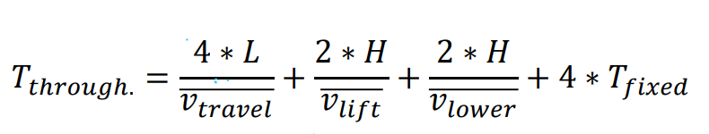The throughput time Tthrough is calculated as,*

***T****through* ***= 276.4 seconds***

*Where, Tfixed is 60 seconds and velocities are reported in Table 11.2*

1. *RMS Internal Logistics*

***Number of Forklifts required***

*To calculate number of forklifts required for warehouse operations,*

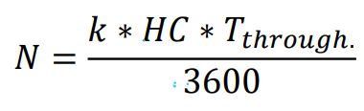

*Where, k – safety factor is assumed as 1.2, therefore, number of forklifts required ≈ 2*

***Actual Handling Capacity***

*Actual Handling capacity of the warehouse is calculated by the following formula,*

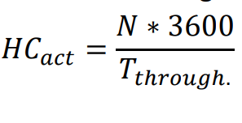

***HCact = 26 LU/h***

***Internal logistic operators***

|  |  |
| --- | --- |
| ***Warehouse operators*** | |
| *Forklift operators* | *2* |
| *Forklift supervisors* | *2* |
| *Warehouse managers* | *2* |
| *Picking area operators (Razor)* | *2* |
| ***Total*** | ***8*** |

*To efficiently operate the warehouse and keeping in check the load on each operator, we require one* ***forklift operator*** *per forklift to carry the receiving, stocking, retrieving of load units from warehouse and* ***two supervisors*** *one for each product to oversee and assist the forklift drivers with their operations.*

***Warehouse managers*** *perform record keeping tasks of the inventories, keeping track of incoming and outgoing load units working in tandem with the production area, their job entails ensuring a quick and smooth flow of load units for production. Furthermore, they also perform overall visual inspection of the load units and ensure quality and report damaged goods.*

***Picking area operators*** *are responsible for feeding the razor production lines with load units (odette) from picking area to respective workstation as per demand. Considering the load, two operators are required to perform the picking area operations, as mentioned previously we opt for* ***automated guided vehicles (AGVs)*** *instead of manually operated low lift trucks to feed odette boxes to the workstations, reducing reliability on manual workforce as well as time to feed the load units to workstation.*

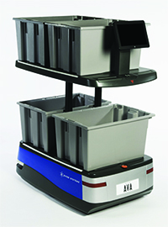

*The benefits of using AGVs,*

* *Fast and agile operations, reducing travel time for larger distances.*
* *Safe navigation on pre-planned path, increasing workplace safety.*
* *Fully automated, reducing human errors.*
* *Manual operators might undergo fatigue due to constant feeding operations.*
* *Small and compact, reducing aisle width requirement.*
* *Reduces labor costs, more efficient and consistent.*

[*6 river systemsTM AGV AVA*](https://6river.com/)

1. *Definition of LU for FPS*
2. ***Hairdryer***

*During the receiving phase, Euro 2 Pallets were utilized (120x100x210 cm). To avoid extra costs from the purchase of further pallets, they will be used as the load unit. This results in the spatial capacity of the load unit being 120x100x19.5(h) cm, which could, technically, hold 380 hairdryer boxes. However, this would make it exceedingly hard to secure them on the load unit with fastening belts. In order to facilitate this task, we define a* ***secondary box with dimensions 60x50x30 (h) cm****, which can hold 15 hairdryer boxes [30x20x10 (h) cm]. This makes the load unit’s hairdryer capacity 360. Taking into account demand, this means 67 LU would be shipped every week. Looking at the weight aspect, taking the secondary box’s weight as 860g (Q/LU=24) and the product box to be 180g (Q/LU=360), the weight EPAL 2 will have to support is 270kg, which is much lower than the recommended 1250kg, hence there are no weight constraints when it comes to load units of the finished product (weight of the hairdryer itself is 750g).*

*Therefore, the load unit chosen for the finished goods storage is the Euro 2 Pallet due to convenience and the possibility to save money, but most importantly due to its suitability to the task. Said load unit can hold 360 hairdryers, is constituted of 24 secondary boxes. Each LU will have its own code, which can be scanned both in the finished products storage and at the final destination point to ensure the absence of shipping problems.*

*Weight of Cardboard Boxes:* [*https://www.uline.com/BL_440/Lightweight-32-ECT-Boxes*](https://www.uline.com/BL_440/Lightweight-32-ECT-Boxes)

1. ***Razor***

*To define the Load unit for Razor’s finished product storage operations, we use* ***Euro Pallet 2*** *in order to have a uniform location size throughout the finished product storage with Hairdryer and Razor. In ideal conditions, the Razor production department produces on average* ***9843 boxed razors*** *(after scrap) for storage and subsequent shipment to regional peripheral warehouses.*

*To increase stability while movement and for ease of distribution, the individual boxes are packed in a secondary larger packing box of dimensions 600x400x150(h), which are then stacked on the pallets.*

|  |  |  |  |  |  |  |
| --- | --- | --- | --- | --- | --- | --- |
| ***EUR pallet 2*** | | ***Razor box*** | | | ***Packing box*** | |
| ***1200*** | ***mm*** | ***200*** | ***mm*** | | ***600*** | ***mm*** |
| ***1000*** | ***mm*** | ***150*** | ***mm*** | | ***400*** | ***mm*** |
| ***1950*** | ***mm*** | ***75*** | ***mm*** | | ***150*** | ***mm*** |
| ***Weight*** | | | | | | |
| ***Razor box*** | | | | ***320 g*** | | |
| ***Packing box*** | | | | ***5.54 kg*** | | |
| ***Pallet*** | | | | ***340.1 kg*** | | |

*Number of Razor boxes per packing box-****16 pcs***

*Number of Packing boxes per pallet-****52 pcs***

*Number of Razor boxes per pallet-****832 pcs***

*The packing is done in way to optimize the spatial arrangement and keeping in check the weight limits.*

*As reported in table 9b.1, the pallet is well under the safety working load of 1250 kg of EPAL 2. The weights include individual weights of razor box (considered 100g) and of packing box (1 kg).*

*Table 9b.1*

*Based on the calculations made above, we obtain* ***the number of LU produced in one production day which is equal to 12 LU.***

*Finally, we obtain a storage analysis chart for whole finished product storage reported below;*

|  |  |  |  |  |  |  |  |  |  |  |  |  |
| --- | --- | --- | --- | --- | --- | --- | --- | --- | --- | --- | --- | --- |
| ***Code*** | ***Desc.*** | ***Unit Load*** | | | | ***Quantity*** | | | | ***Material Handling*** | | |
| ***Type*** | ***Capacity (pcs)*** | ***Size (mm)*** | ***Weight (kg)*** | ***Safety stock*** | ***Max*** | ***Avg.*** | ***Planned*** | ***Method*** | ***Spec.(mm)*** | ***Area (sqm)*** |
| A | Hairdryer | EUR pallet 2 | 360 | 1200x1000 x1950(h) | 270 | 268 | 335 | 167.5 | 335 | pallet rack | 1300x1100 x2050(h) | 1.43 |
| B | Electric Razor | EUR pallet 2 | 832 | 1200x1000 x1950(h) | 340.1 | 240 | 300 | 150 | 300 | pallet rack | 1300x1100 x2050(h) | 1.43 |

*Table 9.1 – SAC finished product storage*

1. *Finished Material Flows*
   1. ***Inventory flows and shipping***

*The finished product storage follows a similar storage philosophy as the raw material storage which is a* ***product-oriented storage*** *with* ***fixed allocation criteria****. To sustain any change in demand a* ***safety stock corresponding to the production of 20 days for both products is considered****. The shipment quantity fixed by the client is equivalent to production corresponding to a week (5 days) for both products.*

1. ***Hairdryer***

*At the end of the production line, the hairdryers are placed in a primary boxes with dimensions 30x20x10 (h) cm and then grouped with other hairdryers in the secondary box described previously in the Task 9. Those secondary boxes are later placed on pallet and delivered to the common finished products storage via forklift trucks. Recalling the production pace we have,* ***13.4 Load Units will be produced in one shift****, which accounts for* ***1.68 Load Units per hour****.*

*The weekly demand will thus be equal to* ***67 LU****, the related Safety Stock value (which is equal to 20 days demand), will be equal to* ***268 LU****. The peak value of the inventory equals to the 25 days demand:* ***335 LU.*** *The reference 20-days inventory flow is shown in the diagram below. The first 20 days from the start of the production the storage is being filled to reach the peak inventory value.*

1. ***Razor***

*The individual razor boxes are placed in packing box and then are palletized at the packing area as explained in report 2, the pallets are then carried by forklifts to the finished product storage. On average* ***12 LU are produced in one shift****. The corresponding input cycle handling capacity for razor is equal to 1.5 LU/h.*

***Safety Stock****;*

*S.S. = (no. of LU per day) x 20 days*

***S.S. = 240 LU***

***Total demand;***

*D = (no. of LU per day) x 5 days*

***D = 60 LU/week***

***Thus, on average 60 LU of razor must be delivered to the regional warehouse in a week.***

*Figure 10.1b.1 visualizes the flow of LU through the finished product storage.*

*Figure 10.1b.1 – FPS flow for a reference period of 90 days*

*The figure shows the data from day 20, which corresponds to achieve the desired level safety stock. The red line and blue line represent different shipping strategies explained in section 10.2. The table corresponding to the figure is reported in Appendix B table 3.*

* 1. ***Planning of shipping items***

*It is assumed both products are shipped to the same regional peripheral warehouse, and thus a common shipping strategy for both the products is required. Furthermore, as Mondays and Wednesdays are scheduled for receiving the raw materials, we consider only Tuesdays, Thursdays and Fridays for shipping the finished product to minimize the load on warehouse operators. Shipping strategies for both products are explained below.*

1. ***Hairdryer***

*Since the weekly demand for hairdryers is 23 782, with possibility of having three shipments per week, we nonetheless use the one-day shipment strategy, same with the Razor Department. The shipment volume equals exactly to the week demand –* ***67 LU****. The reasoning for choosing the one-day shipment strategy is explained in the part B.*

1. ***Razor***

*To reach the desired level of safety stock, shipments are not scheduled in the initial four weeks where the storage is filled with 240 LU (SS),* ***from week 5 we schedule shipments****.*

*To find the optimal shipping schedule, we consider two strategies –*

1. *One shipment of 60 LU per week.*
2. *Three shipments of 20 LU each per week.*

*With respect* ***to******reduce the logistical costs of shipping*** *(fuel, driver wages, and transit time) the option 1 is best fit with less number of trips, the drawback for this approach is increase in storage and handling capacities, for the first option the storage capacity corresponding to peak inventory is 300 LU while, the later requires only 268 LU. As for the handling capacity, from last report the actual handling capacity was significantly higher than required, and it is assumed that the plant functions for multiple years and investing in a slightly larger storage and handling capacities is better than incurring larger constant shipping costs.*

***Finally, we opt for the first option, with shipping of 60 LU once a week on Friday. The output cycle handling capacity for razor is thus 7.5 LU/h on shipping day.***

***Razor storage capacity (peak inventory) is 300 LU.***

***The corresponding replenishment cycle is 5 days.***

***Number of trucks for shipping***

***The delivery of a total 127 LU ( 67 Hairdryer, 60 Razor) is scheduled on a same day of the week which is Friday*** *of each week from week 5. We use the same trucks used for Hairdryer receiving from the raw material warehouse operations to cut overall costs.*

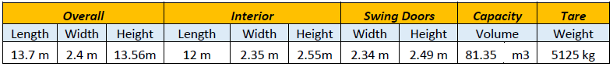

*Volume of delivery = pallet vol. x no. of LU = 312 m3*

***No. of trucks required = Vol. of delivery/Vol. of truck ≈ 4 Trucks***

*We need just one additional truck from the RMS receiving operations.*

*Finally, we obtain a total inventory curve for Hairdryer and Razor, reported below. We can observe the peak inventory of 635 LU and the sudden drops correspond to shipping days (i.e. Friday).*

*Figure 10.2.1 – Total Inventory flow for 90 days*

1. *Finished Products Warehouse and Storage* 
   1. ***Static Sizing***

*We follow product-oriented strategy, like the raw material storage with fixed allocation criteria, where each row (module) is allocated to single product.*

*SC = 335 + 300 =* ***635 LU***

*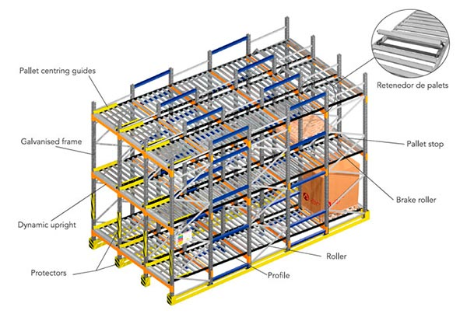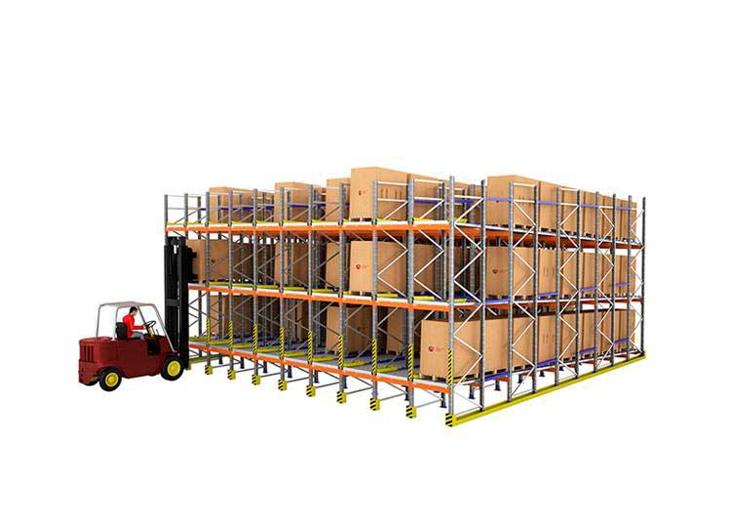As the storage capacity is not small to use selective or drive in racks, neither is it too large to justify investment in an automated storage system, we choose a live storage racking system in our finished product storage.*

*Figure 11.1.1 – Storage Rack overall and detailed view*

*Features:*

*A single row can hold multiple LU.*

*Eliminating secondary aisle space, reducing aisle allowance significantly, reducing waste.*

*Use of roller pins and slight inclination moves LU from loading aisle to unloading aisle with gravity.*

***First in First out philosophy is followed****.*

***Location specification***

|  |  |  |  |  |  |  |  |
| --- | --- | --- | --- | --- | --- | --- | --- |
| ***Load Unit Size*** | | |  | ***LU Location Size*** | | | |
| *Length* | *1200* | *mm* |  | ***L*** | *Length* | ***1300*** | ***mm*** |
| *Width* | *1000* | *mm* |  | ***w*** | *Width* | ***1100*** | ***mm*** |
| *Height* | *1950* | *mm* |  | ***h*** | *Height* | ***2050*** | ***mm*** |

*To define the location size, we consider the dimensions of EURO pallet 2 with enough clearance of 100mm on both sides as well as height limit of 2100mm. Table 11.1.1*

***Choice of Forklifts***

|  |  |  |
| --- | --- | --- |
| ***Forklift's Characteristics***  ***RX 60-25L/600/Li-ion*** | | |
| *Mast type* | *Triplex* | |
| *Lift height* | *7390* | mm |
| *Working aisle* | *1200* | mm |
| *Turning radius* | *2245* | mm |
| *Avg. travel speed* | *18* | km/h |
| *Avg. lifting speed* | *0.56* | m/s |
| *Avg. lowering speed* | *0.45* | m/s |

*We use the same forklifts used in raw material warehouse operations to operate the finished product storage.*

*Table 11.1.2 - FLT specifications.*

***Basic module***

*We store 6 LU back to back in one module, therefore* ***b = 6 x l = 7.8 m; a = 1.1m***

*Whereas,* ***c = 2 x turning radius of FLT = 4.490 m***

**

*Figure 11.1.2 -Basic module*

***Area of basic module,***

***Abm = a x (b + 2c)***

***Therefore, Abm = 18.458 m2***

***Number of levels;***

*Nlevel = int ( lift height/ h ) + 1, Therefore the* ***number of levels is 4.***

***Number of LU per module;***

*N(lu) = 6 x Nlevel* [LU], is ***24 LU***

***Theoretical footprint;***

*alu = Abm /N(lu)* [m2/LU], *therefore* ***theoretical footprint is 0.77 m2/LU***

***Theoretical Storage area;***

*Asto,th = SC x alu , the theoretical* ***storage area required is 488 m2***

***Selectivity***

*To calculate the selectivity of the module, we see that for each module we can directly access the first and the last column, which is equal to 4 x 2 = 8 LU, therefore the selectivity for the planned storage rack is equal to 8 ÷ N(lu) = 0.33 or* ***selectivity is equal to 33.33%***

***Layout of warehouse***

***We assume the input and output point at the middle of the aisle.***

***Uid (Aisle length) = no. of modules x width of module***

*As the allocation criteria is fixed, each module stores only one type of product. To calculate number of modules required we find individual number of modules required by each product using the following equation,*

*No. of modules = SC ÷ N(lu), we obtain* ***14 modules for Hairdryer and 13 modules for razor.***

***Therefore, total number of modules required is 27.***

***Thus****,* ***Uid = 27 x a ≈ 30 m***

***Vid (Module length) = aisle widths + b***

***Therefore Vid = (2 x c) + b ≈ 17 m***

***Actual storage area = 510 m2***

***The actual storage capacity = no. modules x N(lu) = 648 LU.***

***SCact > SC, therefore the planned layout is verified.***

***Performance indices***

***The Rotation Index.***

*To obtain the Rotation Index, we consider the flow of inventory over the 70 days (14 working weeks). The Figure 10.2.1 provided in the Task 10 is used as a reference.*

*For the Hairdryer, the peak inventory Qmax equals to* ***335 LU*** *and is reached* ***14 times*** *during that period. The average inventory equals to 335 / 2 =* ***167.5 LU****. Thus, the rotation index is*

$$R_{hairdryer}= \frac{14*Q_{max}}{I_{avg}}=28$$

*For the Razor, Qmax is* ***300 LU*** *and is reached* **14 times** *during the same period as well. The average inventory is then* ***150 LU****. Thus, the rotation index is*

$$R_{razor}= \frac{14*Q_{max}}{I_{avg}}=28$$

*As it is seen, the rotation indices are equal, which is not a coincidence. Both departments use the same shipping (once a week, same day) and storage filling strategies (gradual daily delivery) which implies that the turnover will be the same.*

*This relatively high rotation index is due to the frequent charging and discharging of the finished products storage (every week), this is justified by a high demand and hence – the production rate.*

* 1. ***Dynamic Sizing***

*To perform the dynamic sizing of the warehouse, we consider the input and output cycle through the FPS.*

***Input Cycle***

*For input cycle we consider the handling capacity required to move LU from production area to storage. The handling capacity required for* ***Hairdryer is 1.675 LU/h and for Razor is 1.5 LU/h.***

*Therefore, total* ***HCin = 3.175 LU/h.***

***Output Cycle***

*As we ship the both products on the same day, the handling capacity HCout is the total handling capacity required to unload the shipping quantity of 127 LU. Therefore,* ***HCout is equal to 15.875 LU/h.***

*Total maximum handling capacity required for Finished product storage operations is sum of HCin + HCout which is equal to* ***HC = 19.05LU/h.***

*We now calculate the average distance (L) and vertical distance (H) in raising and lowering from level travelled by a forklift in the warehouse as,*

***L = 4 x (aisle length/4) = 30 m***

***H = (Nlevel-1)/2 x h = 3.075 m***

*The throughput time Tthrough is calculated as,*

***T****through* ***= 288.4 seconds***

*Where, Tfixed is 60 seconds and velocities are reported in Table 11.2*

1. *FPS Internal Logistics*

***Number of Forklifts required***

*To calculate number of forklifts required for warehouse operations and to minimize redundant procurement of additional FLTs, we use the same forklifts used in RMS operations. Therefore, we also need to consider the maximum output handling capacity required for the RMS operations, which is equal to 3.675 LU/h, therefore the total* ***Handling Capacity is equal to 23 LU/h***

**

*Where, k – safety factor is assumed as 1.2, therefore,* ***total number of forklifts required ≈ 3*** *which is one more than the number of FLTs required in RMS.*

***Actual Handling Capacity***

*Actual Handling capacity of the warehouse is calculated by the following formula,*

**

***HCact = 37.5 LU/h***

*As HCact > HC, the number of forklifts required is verified.*

***Internal logistic operators***

|  |  |
| --- | --- |
| ***Warehouse operators*** | |
| *Forklift operators* | *3* |
| *Forklift supervisors* | *1* |
| *Warehouse managers* | *1* |
| ***Total*** | ***5*** |

*To efficiently operate the warehouse and keeping in check the load on each operator, we require one* ***forklift operator*** *per forklift to carry the stocking and retrieving of load units from warehouse and* ***one supervisor*** *for both products to oversee and assist the forklift drivers with their operations.*

***Warehouse manager*** *performs record keeping tasks of the inventories, keeping track of incoming and outgoing load units working in tandem with the production area.*

1. *Manual Material Handling*

|  |  |  |  |  |  |  |  |  |  |  |  |  |  |  |  |  |  |  |  |  |  |  |  |  |  |  |  |  |  |  |  |  |  |  |  |  |  |  |  |  |  |  |  |  |  |  |  |  |  |  |  |  |  |  |  |  |  |  |  |  |  |  |  |  |  |  |  |  |  |  |  |  |  |  |  |  |  |  |  |  |  |  |  |  |  |  |  |  |  |  |  |  |  |  |  |  |  |  |  |  |  |  |  |  |  |  |  |  |  |  |  |  |  |  |  |  |  |  |  |  |  |  |  |  |  |  |  |  |  |  |  |  |  |  |  |  |  |  |  |  |  |  |  |  |  |  |  |  |  |  |  |  |  |  |  |  |  |  |  |  |  |  |  |  |  |  |  |  |  |  |  |  |  |  |  |  |  |  |  |  |  |  |  |  |  |  |  |  |  |  |  |  |  |  |  |  |  |  |  |  |  |  |  |  |  |  |  |  |
| --- | --- | --- | --- | --- | --- | --- | --- | --- | --- | --- | --- | --- | --- | --- | --- | --- | --- | --- | --- | --- | --- | --- | --- | --- | --- | --- | --- | --- | --- | --- | --- | --- | --- | --- | --- | --- | --- | --- | --- | --- | --- | --- | --- | --- | --- | --- | --- | --- | --- | --- | --- | --- | --- | --- | --- | --- | --- | --- | --- | --- | --- | --- | --- | --- | --- | --- | --- | --- | --- | --- | --- | --- | --- | --- | --- | --- | --- | --- | --- | --- | --- | --- | --- | --- | --- | --- | --- | --- | --- | --- | --- | --- | --- | --- | --- | --- | --- | --- | --- | --- | --- | --- | --- | --- | --- | --- | --- | --- | --- | --- | --- | --- | --- | --- | --- | --- | --- | --- | --- | --- | --- | --- | --- | --- | --- | --- | --- | --- | --- | --- | --- | --- | --- | --- | --- | --- | --- | --- | --- | --- | --- | --- | --- | --- | --- | --- | --- | --- | --- | --- | --- | --- | --- | --- | --- | --- | --- | --- | --- | --- | --- | --- | --- | --- | --- | --- | --- | --- | --- | --- | --- | --- | --- | --- | --- | --- | --- | --- | --- | --- | --- | --- | --- | --- | --- | --- | --- | --- | --- | --- | --- | --- | --- | --- | --- | --- | --- | --- | --- | --- | --- | --- | --- | --- | --- | --- | --- | --- |
| ***HAIRDRYER******RAZOR*** *Requirements of Raw Materials at Workstation 1 are as in the table shown below,*   |  |  |  |  | | --- | --- | --- | --- | | ***Raw Material*** | ***Weight odette*** | ***Quantity per Odette*** | ***Daily demand*** | | Side grip L | 3.78 | 690 | 1269 | | Side grip R | 3.78 | 690 | 1269 | | Back Shell Assy | 1.27 | 78 | 1269 | | Trimmer assy | 4.53 | 4870 | 1269 |  * *Pre-programmed AGV collects Raw material from RM warehouse picking area and feeds the respective workstations with the Odette.* * *Manual Work handling is required to shift the loads from AGV to the dedicated workstation RM storage.* * *AGVs stop for 5 mins at each workstation for the transfer of loads.* * *Odette do not need any significant control while handling.*   ***To assess the safety of this manual material handling we applying NIOSH for better ergonomics.***  *For the required task, variables are as follows*   |  |  |  |  |  |  |  |  |  |  |  |  | | --- | --- | --- | --- | --- | --- | --- | --- | --- | --- | --- | --- | | RM | Odette weight | Hand location (cm) | | | | Vertical distance (cm) | Asymmetric angle | | Frequency rate | Duration hours | Coupling | |  | Kg | Origin | | Destination | |  | Origin | Destination | lifts/min | Hrs |  | |  |  | H | V | H | V | D | A | A | F |  | C | | 1 | 3.78 | 25 | 120 | 25 | 120 | 0 | 0 | 0 | 0.2 | <1 | Good | | 2 | 3.78 | 25 | 120 | 25 | 120 | 0.2 | | 3 | 1.27 | 25 | 80 | 25 | 80 | 0.2 | | 4 | 4.53 | 25 | 80 | 25 | 80 | 0.2 |   *To finally calculate NIOSH equation, and to obtain RWL and LI, multipliers were obtained for each variable using tables .*  **LC x HM x VM x DM x AM x FM x CM = RWL**  Using Load constant as 23Kg,   |  |  |  |  |  |  |  |  |  |  | | --- | --- | --- | --- | --- | --- | --- | --- | --- | --- | | Items | LC | VM | DM | HM | AM | CM | FM | RWL | LI | | SR | 23 | 0.99 | 1 | 1 | 0.71 | 1 | 1 | 16.1667 | 0.233814 | | SL | 23 | 0.99 | 1 | 1 | 0.71 | 1 | 1 | 16.1667 | 0.233814 | | BSA | 23 | 0.87 | 1 | 1 | 0.71 | 1 | 1 | 14.2071 | 0.089392 | | TA | 23 | 0.87 | 1 | 1 | 0.71 | 1 | 1 | 14.2071 | 0.318855 |      |  |  |  | | --- | --- | --- | | Items | FIRWL | FILI | | SR | 16.17 | 0.233814 | | SL | 16.17 | 0.233814 | | BSA | 14.21 | 0.089392 | | TA | 14.21 | 0.318855 |   *The task is characterized as variable lifting loads, therefore, to calculate and apply cumulative Variable Lifting Index (VLI), FIRWL and FILI were calculated.*   |  |  |  |  |  |  |  |  |  | | --- | --- | --- | --- | --- | --- | --- | --- | --- | | Rank | Items | RWL | LI | F_Cum | FM_Cum | FILI | Δ | ΔVLI | | 1 | TA | 14.2071 | 0.318855 | 0.2 | 1 | // | // | 0.089392 | | 2 | SL | 16.1667 | 0.233814 | 0.4 | 0.98 | 0.233814 | 0.020408 | 0.004772 | | 3 | RL | 16.1667 | 0.233814 | 0.6 | 0.96 | 0.233814 | 0.021259 | 0.004971 | | 4 | BSA | 14.2071 | 0.089392 | 0.8 | 0.95 | 0.089392 | 0.010965 | 0.00098 | | ***VLI*** | | | | | | | | ***0.100114*** |   *Arranging loads as per descending order of their respective LI, we assess VLI as,*    ***Variable Loading Index (VLI)*** *as per revised NIOSH method comes out as* ***0.100114,*** *this signifies that design of the lifting method is* ***Safe*** *and there is* ***Minimal risk*** *to the health of employees.*   1. *Plant Layout* |
|  |

***Appendix A***

**

*Table of general data*

**

*Table 1. ABC classification*



*Table 2. Inventory data for Economical approach.*



*Table 3. Inventory data for Raw Material approach*



*Table 3 – Hairdryer FPS LU flow for the first 50 days*

***Appendix B***

|  |  |  |  |  |  |  |  |  |  |  |  |  |  |  |  |  |  |  |
| --- | --- | --- | --- | --- | --- | --- | --- | --- | --- | --- | --- | --- | --- | --- | --- | --- | --- | --- |
| FROM Supp to RMS to PICKING - Razor | | | | | | | | | | | | | | | | | | |
| week | days | 1 | 2 | 3 | 4 | 5 | 6 | 7 | 8 | 9 | 10 | 11 | 12 | 13 | 14A | 14B | 15 | 16 |
| cons | | 0.2 | 0.4 | 1 | 0.2 | 0.13 | 0.4 | 23 | 0.2 | 0.07 | 1 | 0.07 | 0.07 | 0.07 | 0.13 | 0.13 | 0.67 | 0.07 |
| day 0 | | 3 | 6 | 15 | 3 | 2 | 6 | 23 | 3 | 1 | 15 | 1 | 1 | 1 | 2 | 2 | 10 | 1 |
| 1 | Mon | 2.8 | 5.6 | 14 | 2.8 | 1.87 | 5.6 | 23 | 2.8 | 0.93 | 14 | 0.93 | 0.93 | 0.93 | 1.87 | 1.87 | 9.33 | 0.93 |
| Tue | 2.6 | 5.2 | 13 | 2.6 | 1.73 | 5.2 | 21.5 | 2.6 | 0.87 | 13 | 0.87 | 0.87 | 0.87 | 1.73 | 1.73 | 8.67 | 0.87 |
| Wed | 3 | 6 | 15 | 2.4 | 1.6 | 4.8 | 19.9 | 2.4 | 0.8 | 12 | 0.8 | 0.8 | 0.8 | 1.6 | 1.6 | 8 | 0.8 |
| Thu | 2.8 | 5.6 | 14 | 2.2 | 1.47 | 4.4 | 18.4 | 2.2 | 0.73 | 11 | 0.73 | 0.73 | 0.73 | 1.47 | 1.47 | 7.33 | 0.73 |
| Fri | 2.6 | 5.2 | 13 | 2 | 1.33 | 4 | 16.9 | 2 | 0.67 | 10 | 0.67 | 0.67 | 0.67 | 1.33 | 1.33 | 6.67 | 0.67 |
| 2 | Mon | 2.4 | 4.8 | 12 | 3 | 1.2 | 6 | 15.3 | 1.8 | 0.6 | 15 | 0.6 | 0.6 | 0.6 | 1.2 | 1.2 | 6 | 0.6 |
| Tue | 2.2 | 4.4 | 11 | 2.8 | 1.07 | 5.6 | 13.8 | 1.6 | 0.53 | 14 | 0.53 | 0.53 | 0.53 | 1.07 | 1.07 | 5.33 | 0.53 |
| Wed | 2 | 4 | 10 | 2.6 | 2 | 5.2 | 12.3 | 3 | 1 | 13 | 1 | 1 | 1 | 2 | 2 | 10 | 1 |
| Thu | 1.8 | 3.6 | 9 | 2.4 | 1.87 | 4.8 | 10.7 | 2.8 | 0.93 | 12 | 0.93 | 0.93 | 0.93 | 1.87 | 1.87 | 9.33 | 0.93 |
| Fri | 1.6 | 3.2 | 8 | 2.2 | 1.73 | 4.4 | 9.2 | 2.6 | 0.87 | 11 | 0.87 | 0.87 | 0.87 | 1.73 | 1.73 | 8.67 | 0.87 |
| 3 | Mon | 1.4 | 2.8 | 7 | 2 | 1.6 | 4 | 7.67 | 2.4 | 0.8 | 10 | 0.8 | 0.8 | 0.8 | 1.6 | 1.6 | 8 | 0.8 |
| Tue | 1.2 | 2.4 | 6 | 1.8 | 1.47 | 3.6 | 6.13 | 2.2 | 0.73 | 9 | 0.73 | 0.73 | 0.73 | 1.47 | 1.47 | 7.33 | 0.73 |
| Wed | 1 | 2 | 5 | 1.6 | 1.33 | 3.2 | 4.6 | 2 | 0.67 | 8 | 0.67 | 0.67 | 0.67 | 1.33 | 1.33 | 6.67 | 0.67 |
| Thu | 0.8 | 1.6 | 4 | 1.4 | 1.2 | 2.8 | 3.07 | 1.8 | 0.6 | 7 | 0.6 | 0.6 | 0.6 | 1.2 | 1.2 | 6 | 0.6 |
| Fri | 0.6 | 1.2 | 3 | 1.2 | 1.07 | 2.4 | 1.53 | 1.6 | 0.53 | 6 | 0.53 | 0.53 | 0.53 | 1.07 | 1.07 | 5.33 | 0.53 |
| 4 | Mon | 0.4 | 0.8 | 2 | 1 | 0.93 | 2 | 23 | 1.4 | 0.47 | 5 | 0.47 | 0.47 | 0.47 | 0.93 | 0.93 | 4.67 | 0.47 |
| Tue | 0.2 | 0.4 | 1 | 0.8 | 0.8 | 1.6 | 21.5 | 1.2 | 0.4 | 4 | 0.4 | 0.4 | 0.4 | 0.8 | 0.8 | 4 | 0.4 |
| Wed | 3 | 6 | 15 | 0.6 | 0.67 | 1.2 | 19.9 | 1 | 0.33 | 3 | 0.33 | 0.33 | 0.33 | 0.67 | 0.67 | 3.33 | 0.33 |
| Thu | 2.8 | 5.6 | 14 | 0.4 | 0.53 | 0.8 | 18.4 | 0.8 | 0.27 | 2 | 0.27 | 0.27 | 0.27 | 0.53 | 0.53 | 2.67 | 0.27 |
| Fri | 2.6 | 5.2 | 13 | 0.2 | 0.4 | 0.4 | 16.9 | 0.6 | 0.2 | 1 | 0.2 | 0.2 | 0.2 | 0.4 | 0.4 | 2 | 0.2 |
| 5 | Mon | 2.4 | 4.8 | 12 | 3 | 0.27 | 6 | 15.3 | 0.4 | 0.13 | 15 | 0.13 | 0.13 | 0.13 | 0.27 | 0.27 | 1.33 | 0.13 |
| Tue | 2.2 | 4.4 | 11 | 2.8 | 0.13 | 5.6 | 13.8 | 0.2 | 0.07 | 14 | 0.07 | 0.07 | 0.07 | 0.13 | 0.13 | 0.67 | 0.07 |
| Wed | 2 | 4 | 10 | 2.6 | 2 | 5.2 | 12.3 | 3 | 1 | 13 | 1 | 1 | 1 | 2 | 2 | 10 | 1 |
| Thu | 1.8 | 3.6 | 9 | 2.4 | 1.87 | 4.8 | 10.7 | 2.8 | 0.93 | 12 | 0.93 | 0.93 | 0.93 | 1.87 | 1.87 | 9.33 | 0.93 |
| Fri | 1.6 | 3.2 | 8 | 2.2 | 1.73 | 4.4 | 9.2 | 2.6 | 0.87 | 11 | 0.87 | 0.87 | 0.87 | 1.73 | 1.73 | 8.67 | 0.87 |
| 6 | Mon | 1.4 | 2.8 | 7 | 2 | 1.6 | 4 | 7.67 | 2.4 | 0.8 | 10 | 0.8 | 0.8 | 0.8 | 1.6 | 1.6 | 8 | 0.8 |
| Tue | 1.2 | 2.4 | 6 | 1.8 | 1.47 | 3.6 | 6.13 | 2.2 | 0.73 | 9 | 0.73 | 0.73 | 0.73 | 1.47 | 1.47 | 7.33 | 0.73 |
| Wed | 1 | 2 | 5 | 1.6 | 1.33 | 3.2 | 4.6 | 2 | 0.67 | 8 | 0.67 | 0.67 | 0.67 | 1.33 | 1.33 | 6.67 | 0.67 |
| Thu | 0.8 | 1.6 | 4 | 1.4 | 1.2 | 2.8 | 3.07 | 1.8 | 0.6 | 7 | 0.6 | 0.6 | 0.6 | 1.2 | 1.2 | 6 | 0.6 |
| Fri | 0.6 | 1.2 | 3 | 1.2 | 1.07 | 2.4 | 1.53 | 1.6 | 0.53 | 6 | 0.53 | 0.53 | 0.53 | 1.07 | 1.07 | 5.33 | 0.53 |
| 7 | Mon | 0.4 | 0.8 | 2 | 1 | 0.93 | 2 | 23 | 1.4 | 0.47 | 5 | 0.47 | 0.47 | 0.47 | 0.93 | 0.93 | 4.67 | 0.47 |
| Tue | 0.2 | 0.4 | 1 | 0.8 | 0.8 | 1.6 | 21.5 | 1.2 | 0.4 | 4 | 0.4 | 0.4 | 0.4 | 0.8 | 0.8 | 4 | 0.4 |
| Wed | 3 | 6 | 15 | 0.6 | 0.67 | 1.2 | 19.9 | 1 | 0.33 | 3 | 0.33 | 0.33 | 0.33 | 0.67 | 0.67 | 3.33 | 0.33 |
| Thu | 2.8 | 5.6 | 14 | 0.4 | 0.53 | 0.8 | 18.4 | 0.8 | 0.27 | 2 | 0.27 | 0.27 | 0.27 | 0.53 | 0.53 | 2.67 | 0.27 |
| Fri | 2.6 | 5.2 | 13 | 0.2 | 0.4 | 0.4 | 16.9 | 0.6 | 0.2 | 1 | 0.2 | 0.2 | 0.2 | 0.4 | 0.4 | 2 | 0.2 |
| *Table 1* | | | | | | | | | | | | | | | | | | |

|  |  |  |  |  |  |  |  |  |  |  |  |  |  |  |  |  |  |
| --- | --- | --- | --- | --- | --- | --- | --- | --- | --- | --- | --- | --- | --- | --- | --- | --- | --- |
| PICKING AREA FLOW -Razor | | | | | | | | | | | | | | | | | |
| days | 1 | 2 | 3 | 4 | 5 | 6 | 7 | 8 | 9 | 10 | 11 | 12 | 13 | 14A | 14B | 15 | 16 |
| cons | 48 | 96 | 256 | 48 | 32 | 96 | 120 | 48 | 8 | 256 | 8 | 16 | 8 | 24 | 24 | 168 | 0.5 |
| 0 | 256 | 256 | 256 | 256 | 256 | 256 | 160 | 256 | 120 | 256 | 120 | 240 | 120 | 256 | 256 | 256 | 8.0 |
| 1 | 208 | 160 | 256 | 208 | 224 | 160 | 40 | 208 | 112 | 256 | 112 | 224 | 112 | 232 | 232 | 256 | 7.47 |
| 2 | 160 | 64 | 256 | 160 | 192 | 64 | 80 | 160 | 104 | 256 | 104 | 208 | 104 | 208 | 208 | 256 | 6.9 |
| 3 | 112 | 224 | 256 | 112 | 160 | 224 | 120 | 112 | 96 | 256 | 96 | 192 | 96 | 184 | 184 | 256 | 6.4 |
| 4 | 64 | 128 | 256 | 64 | 128 | 128 | 0 | 64 | 88 | 256 | 88 | 176 | 88 | 160 | 160 | 256 | 5.9 |
| 5 | 16 | 32 | 256 | 16 | 96 | 32 | 160 | 16 | 80 | 256 | 80 | 160 | 80 | 136 | 136 | 256 | 5.3 |
| 6 | 224 | 192 | 256 | 224 | 64 | 192 | 40 | 224 | 72 | 256 | 72 | 144 | 72 | 112 | 112 | 256 | 4.8 |
| 7 | 176 | 96 | 256 | 176 | 32 | 96 | 80 | 176 | 64 | 256 | 64 | 128 | 64 | 88 | 88 | 256 | 4.3 |
| 8 | 128 | 0 | 256 | 128 | 0 | 0 | 120 | 128 | 56 | 256 | 56 | 112 | 56 | 64 | 64 | 256 | 3.7 |
| 9 | 80 | 160 | 256 | 80 | 192 | 160 | 0 | 80 | 48 | 256 | 48 | 96 | 48 | 40 | 40 | 256 | 3.2 |
| 10 | 32 | 64 | 256 | 32 | 160 | 64 | 160 | 32 | 40 | 256 | 40 | 80 | 40 | 16 | 16 | 256 | 2.7 |
| 11 | 192 | 224 | 256 | 192 | 128 | 224 | 40 | 192 | 32 | 256 | 32 | 64 | 32 | 96 | 96 | 256 | 2.1 |
| 12 | 144 | 128 | 256 | 144 | 96 | 128 | 80 | 144 | 24 | 256 | 24 | 48 | 24 | 72 | 72 | 256 | 1.6 |
| 13 | 96 | 32 | 256 | 96 | 64 | 32 | 120 | 96 | 16 | 256 | 16 | 32 | 16 | 48 | 48 | 256 | 1.1 |
| 14 | 48 | 96 | 256 | 48 | 32 | 96 | 0 | 48 | 8 | 256 | 8 | 16 | 8 | 24 | 24 | 256 | 0.5 |
| 15 | 0 | 0 | 256 | 0 | 0 | 0 | 160 | 0 | 0 | 256 | 0 | 0 | 0 | 0 | 0 | 256 | 0.0 |
| 13 | 256 | 256 | 256 | 256 | 256 | 256 | 256 | 40 | 256 | 120 | 256 | 120 | 240 | 120 | 256 | 256 | 256 |
| *Table 2* | | | | | | | | | | | | | | | | |  |

*Table 3 – Razor LU flow for first 90 days*



|  |  |  |
| --- | --- | --- |
| *Input/day* | 12 | LU/d |
| *Output/week* | 60 | LU/d |

|  |  |
| --- | --- |
|  | *No shipment in initial 4 weeks* |
|  |  |
|  | *Shipping Days* |

***Bibliography***

*Value Stream Mapping Case Study: Guleri, Akhilesh, et al. “APPLICATION OF VSM IN HAIR DRYER MANUFACTURING INDUSTRY: A CASE STUDY.” International Journal For Technological Research In Engineering, July 2015;* [*www.ijtre.com/images/scripts/2015021141.pdf*](http://www.ijtre.com/images/scripts/2015021141.pdf)

1. Refer to Appendix 1 for Constraint table